**A**

**TRAINING PROJECT**

**ON**

**“FIND MY PG”**

SUBMITTED FOR

***BACHELOR OF TECHNOLOGY***

IN

**COMPUTER SCIENCE AND ENGINEERING**

AT



***BMIET COLLEGE OF ENGINEERING***

***SONIPAT***

2019

|  |  |
| --- | --- |
| SUBMITTED TO | SUBMITTED BY |
| Ms. Shikha | NANDITA |
|  | CSE-3rd Year (5th SEM) |
|  | Roll NO.-CSE/17/202 |

**CANDIDATE’S DECLARATION**

I hereby declare that the work presented in this training report entitled **“FindMyPG”**, submitted in partial fulfillment of the requirement for the award of the degree of Bachelor of Technology in **CSE**, submitted to **BMIET, Sonipat ,**is an authentic record of my own work carried out during the period from **5-June-2019** to **20-July-2019** under the guidance of **Girish Kumar Attri.**

The work reported in this project report has not been submitted by me for the award of any other degree or diploma.

Nandita

CSE/17/202

**CERTIFICATE**

This is to certify that the summer training report entitled **FindMyPG”** done by **NANDITA, Roll No. CSE/17/202** is an authentic work carried out by him at **Aptech Computer Education, Pitampura** under my guidance. The matter embodied in this training title/ project work has not been submitted earlier for the award of any degree or diploma to the best of my knowledge and belief.

Girish Kumar Attri

CAH/Sr. IT Trainer

**Acknowledgement**

It has been rightly remarked, “Success is the satisfactory achievement of chosen and desired objective. It is the attainment of the major objects; you earnestly desired and worked for with burning enthusiasm and dedication.”

Before we get into things, I would like to share a few heartfelt words with the people who were part of this project in numerous ways, people who gave unending from the beginning.

The successful completion of the project is a combined effort of a number of people, and all of them have their own importance in the achievement of objective.

I cannot miss this opportunity to thank **Ms. Shikha** as a mentor for her timely support and valuable guidance throughout the project.

I wish to express a deep sense of gratitude to **Mr. Abhinav Juneja**, HOD, Department of Computer Applications, and B.M.I.E.T, who gave me opportunity to undertake my training in an esteemed organization and gently and inspired me toward a bright career.

**Mr. Girish Kumar Attri,** my guide at Exact it solution has a steadying influenced on this project. I thank him even more for his uncanny ability to spot the mistakes I had reviewed many times while doing the project.

Last but not the least I would also like to thank my parents & project mates for being a pillar of strength and support in times of stress & difficulty throughout the project duration.

(Nandita)

## Abstract

Each year many students migrate from their home cities to other cities for their education or work. As Hotel Room prices are very high and out of reach for any middle class person. They seek for rather inexpensive solutions where they can find themselves in a reasonable budget. Paying Guest industry in India is very vast and provides reasonable accommodations to student.

In today’s fast pacing world everyone wants to do their task timely and more conveniently, dealing in Paying Guest business is also the same thing. Property owner who want to rent their properties require a platform which is more convenient for them to deal in their property. Similarly, for a student, who is looking to rent a property for himself/herself wants to have a platform where he or she can look for the best opportunities for his/her need.

**FINDMYPG** as a platform provides opportunities for all students to find an accommodation for themselves as per their requirements.. **Property Bazaar** maintains the database of all PGs enlisted renting. A student can search for a PG from a large dataset. PGs can be filtered using multiple criteria’s. For e.g. a user can search properties having bedrooms, washrooms etc.

**Abbreviations**

|  |  |
| --- | --- |
| AJAX | Asynchronous JavaScript and XML |
| CSS | Cascading Style Sheets |
| DFD | Data Flow Diagram |
| E-R | Entity Relationship |
| HTML | Hypertext Markup Language |
| SQL | Structured Query Language |
| XML | Extensible Markup Language |

## CONTENT

## Candidate's Declaration i

## Certificate ii

**Acknowledgement** iii

**Abstract** iv

**Abbreviations** v

## CHAPTER DESCRIPTION

**Chapter 1: INTRODUCTION**

**Chapter 2: REQUIREMENT ANALYSIS**

**Chapter 3: FEASIBILITY STUDY**

**Chapter 4: SYSTEM DESIGN**

**Chapter 5: DATABASE TABLES**

**Chapter 6: CODING**

**Chapter 7: OUTPUT SCREEN**

**Chapter 8: TESTING**

**Chapter 9: MAINTAINANCE AND EVALUATION**

**Chapter 10: CONCLUSION AND DISCUSSION**

**References and Bibliography**

**Chapter-1**

**Introduction**

**CHAPTER-1 Introduction**

The idea behind this project is to make the Paying Guest business simplified for all users, whether owners or students. Paying Guest business is very huge in itself, which requires a lot of work to be done manually. **FindMyPG** acts as a tool for various PG entities and offers them a single platform to their activities online.

**FindMyPG** provides all services to its users from searching and renting of PGs. It also has a unique search feature which lets the intended buyers to search for properties using various criteria’s. For e.g. a user can look up for a property with specific no. of bedrooms, or within specific budget. This helps them to identify only those properties which are more appropriate for them.

After finding an appropriate property the user can request the owner of the property for the further details. The final deal can only be finalized after both tenant and owner agrees on all terms.

**FindMyPG** promises to its clients to provide the most efficient way of getting the best PG. We are committed to our users and help them to take a wiser decision.

Providing a superior experience, we offer our users/clients an easier, faster, accurate and more secure way to get tenants for your property. **FindMyPG** give its customers ease of doing business. We maintain a strong relationship with our customers/clients.

**1.1 Project purpose**

The main purpose of this website is to give an access to a platform to all those owners who are related to PG Business. An individual can also take benefits from our project by finding the right deal for himself/herself.

FindMyPG manages the list of all propertie. This list helps students/tenants to search through a vast database. Properties can be filtered using various filters and criteria’s. **FindMyPG** has also very useful for the builders who have developed buildings and want to get buyers for their properties.

**1.2 Project scope**

With the affordable access to the Internet every household can now access the World Wide Web. Unlike the older days now everyone from child to old knows how to use internet and are connected to internet. With the popularity of Internet, Online applications have become a trend to interact with the clients. Every company now can connect to their clients/users electronically, without requiring them to visit their offices.

**FindMyPG** has been designed by keeping the same information in mind. **FindMyPG** gives solution to each and every one who is connected to the internet to work from their homes. In the older days, an owner has to visit a lot of agents directly to rent off their properties. This process sometimes could be months long.

**FindMyPG** provides renting services to its users. It also has a unique search feature which lets the intended buyers to search for PGs using various criteria’s. For e.g. a user can look up for a property with specific no. of bedrooms, or within specific budget. This helps them to identify only those properties which are more appropriate for them.

**1.3 Project Objectives**

* The primary object of this project is to connect properties PG owners and tenants/students together.
* Owners needs to have their login accounts. A login form should display before adding properties.
* The Administrator should have all the rights (proposed).
* The Administrator should maintain and verify properties.
* The owner can change the information regarding PG, cancellation of PGs or changing choice.

* The tenant/student can rent with detail of property.

|  |
| --- |
|  |

**1.4 Project Goals**

* **Planned approach towards working**: - The working of the organization should be well organized with the right approach in place. The data must be saved accurately in data stores, which’ll help in getting information from data storage.
* **Accuracy**: - Every project must have some level of accuracy. However, the level of accuracy in the FindMyPG is undecided. A buy and the other sell. Guarantee cannot be confirmed.
* **Reliability**: - The system is highly reliable for the reasons stated above. The system maintains its high reliability because of the various quality check and constraints. These checks help us to maintain the level of reliability users have on their clients.

**Chapter-2**

**Requirement Analysis**

**CHAPTER-2 System Requirement Specifications**

**2.1 Scope:**

With the affordable access to the Internet every household can now access the World Wide Web. Unlike the older days now everyone from child to old knows how to use internet and are connected to internet. With the popularity of Internet, Online applications have become a trend to interact with the clients. Every company now can connect to their clients/users electronically, without requiring them to visit their offices.

Now a day when every task is being perform online, Paying Guest Industry is no exception to that. Paying Guest Actors are taking the advantage of the Internet to reach to wider audience, this not only give them access to large number of users, but also ensures that with the minimum investment they can take maximum benefits. FindMyPG provides its user access to the wider audience such as owners. Prospect tenants/students will have access to all this information and can find the right PG for them within the right budget and in right area.

**FindMyPG** provides renting services to its users. It also has a unique search feature which lets the intended tenants/students to search for properties using various criteria’s. For e.g. a user can look up for a property with specific no. of bedrooms, or within specific budget. This helps them to identify only those properties which are more appropriate for them.

After finding an appropriate property the user can request the owner of the property for the further details. The final deal can only be finalized after both buyer and seller agrees on all terms.

**FindMyPG** promises to its clients to provide the most efficient way of getting the dream property. We are committed to our users and help them to take a wiser decision.

Providing a superior experience, we offer our users/clients an easier, faster, accurate and more secure way to get buyers for your property. **FindMyPG** give its customers ease of doing business. We maintain a strong relationship with our customers/clients.

**2.2 Objectives**

* The primary object of this project is to connect properties PG Owners and tenants together.
* Owners needs to have their login accounts. A login form should display before adding properties.
* The Administrator should have all the rights (proposed).
* The Administrator should maintain and verify properties.
* The Administrator should inform the agents for regarding the property.
* The owner can change the information regarding property, cancellation of property or changing buyer choice.

* The buyer can book property for purchase or rent with detail of property.

**2.3 Overall description:**

**2.3.1 Product Prospective:**

* **Admin’s interface:** Admin’s responsibilities includes handling the entire system. Admin must verify the details entered by its user and must take necessary actions. Every user in the system will be provided a user name and password to access the admin portal.
* **User’s interface:** User can access the system by creating a free account in the website. Account creation gives a user access to uploading properties, requirements and managing their profiles. Buyer of the properties need not to have a user account, they can still access the system without registering on the website. Final sale and purchase of the property can only be performed once a deal has been finalized between seller and purchaser.

**2.3.2 Product Functions:**

* **Our system must save time and money:** Property Bazaar ensures that the buyers and sellers can connect to each other without visiting them to each other directly. This saves a lot money and time for both.
* **Reduce rework:** Early validation means “development and quality teams spend” lessor amount of time on re-work.
* **Improve requirement accuracy:** Industry-oriented story-boarding improves accuracy by promoting effective communication.

**2.3.3 Assumptions and Dependencies:**

**Assumptions:**

* “The code should be free with compilation errors/syntax errors”.
* “The product must have an interface which is simple enough to understand”.

**Dependencies:**

* “All necessary hardware and software are available for implementing and use of the tool”.
* “The proposed system would be designed, developed and implemented based on the software requirements specifications document<,
* “End users should have basic knowledge of computer and we also assure that the users will be given software training documentation and reference material”.
* “The system is not required to save generated reports”.

**2.4 Specific Requirements:**

**Software requirements:**

* Any Version of Web Browser
* Python
* Django

**Hardware requirements:**

* Any processor after Pentium 4.
* Any version of Windows XP or later.
* Min RAM 2 GB.
* Hard Disk 500 GB.

**2.5 Functional and Non-Functional Requirement:**

* **Functional Requirements:**

“Since this project uses database and control, it needs the retrieval of information from the database”. “It needs access of Database from a front end, as ASP.net is a Microsoft Family product, it provides easy linking to the database, along with the flexibility required to develop a user-friendly front end,..

* **Functional Requirements**
  + **Usability: “**The interface should use terms and concepts, which are drawn from the experience of the people who will make most of the system”.
  + **Efficiency: “**The system must provide easy and fast access without consuming more cost”.
  + **Reliability: “**User should never be surprised by the behavior of the system and it is easy to use to stored data and easy to used transfer voice data” (only .wav files)

**2.6 System attributes:**

* **Reliability**

“This system is designed to have very simple database just to cater the exact need of real estate management. It is tested for all the constraints at development stage”.

* **Availability**

“This system will only available till the system on which it is installed is running”.

* **Security**

“This system is provided with authentication without which no user can pass”. “So only the legitimate users are allowed to use the application”. “If the legitimate users share the authentication information then the system is open to outsiders”.

* **Maintainability**

“There will be no maintenance required for the software”. ,The database is provided by the end-user and therefore is maintained by this user,.

* **Portability**

“The system is not portable as it is a standalone application running on single system with no shared database.

**Chapter-3**

**Feasibility Study**

**CHAPTER-3 Feasibility Study**

**4. Introduction**

“A feasibility study aims to objectively and rationally uncover the strengths and weaknesses of an existing business or proposed venture”, “opportunities and threats present in the environment”, “the resources required to carry through”, “and ultimately the prospects for success. In its simplest terms”, “the two criteria to judge feasibility are cost required and value to be attained”.

“Feasibility study is the phase in which the analyst checks that the candidate system is feasible for the organization or not”. “This entails identification, description and evaluation of the system”. “Feasibility is done to select the best system that meets the performance requirement”.

“Preliminary investigation examine project feasibility”, “the likelihood the system will be useful to the organization”. “The main objective of the feasibility study is to test the Technical, Operational and Economical feasibility for adding new modules and debugging old running system”. “All system is feasible if they use unlimited resources and infinite time”. “Feasibility and risk analysis are related to each other”. “If project risk is great, the feasibility of producing quality software is reduced”.

There are aspects in the feasibility study portion of the preliminary investigation:

* Technical Feasibility
* Operational Feasibility
* Economical Feasibility

**3.1 Technical Feasibility**

“A study of function, performance, and constraints that may affect the ability to achieve an acceptable system”. “It is the most difficult area to assess because objectives, functions, and performance are somewhat hazy; anything seems possible if the right assumptions are made”.

“The technical issue usually raised during the feasibility stage of the investigation includes the following”:

* “Does the necessary technology exist to do what is suggested”?
* “Does the proposed equipment have the technical capacity to hold the data required to use the new system”?
* “Will the proposed system provide adequate response to inquiries, regardless of the number or location of users”?
* “Can the system be upgraded if developed [ ?
* “Are there technical guarantees of accuracy, reliability, ease of access and data security”?

**3.1.1 Development Risk**

* “Can the system element be designed so that necessary function and performance are achieved within the constraints uncovered during analysis”?

**3.1.2 Resource availability**

* “Are skilled staffs available to develop the system element in Question”? “Are any other necessary resources (hardware and software) available to build the system”?

**3.1.3 Technology**

* **[[**Has the relevant technology progressed to a state that will support the system”?
* [All of the above consideration also applies to the work I have done”. “As far as developments risks are concerned”, “yes necessary functions and the constraints under which they have to perform have been identified and divided into modules so that each module performs its own assigned task”.
* “As for skilled staff for development is concerned”, “I am the only person performing this task and I have fully understood the problem”. “I am sufficiently equipped with the use of programming and can perform this tasks in the given time constraints”.

“Earlier no system existed to cater to the needs of ‘Secure Infrastructure Implementation System’. The current system developed is technically feasible. Thus it provides an easy access to the users”.

“The database’s purpose is to create, establish and maintain a workflow among various entities in order to facilitate all concerned users in their various capacities or roles”. “Permission to the users would be granted based on the roles specified”. “Therefore, it provides the technical guarantee of accuracy, reliability and security”.

“The software and hard requirements for the development of this project are not many and are already available as free as open source”. “The work for the project is done with the current equipment and existing software technology”. “Necessary bandwidth exists for providing a fast feedback to the users irrespective of the number of users using the system”.

**3.2 Operational Feasibility**

“This study helps us in finding whether the work to be done will be operational with the available staff and within the given time”. “The staff is fully capable of handling information system”. [The IT literacy is of good order and the software has been made in such a way that it becomes easier for the user to answer queries being asked”. “This will facilitate easy use and adoptability of the system”.

“Proposed projects are beneficial only if they can be turned out into information system”. “That will meet the organization’s operating requirements”. “Operational feasibility aspects of the project are to be taken as an important part of the project implementation”. “Some of the important issues raised are to test the operational feasibility of a project includes the following”:

* “Is there sufficient support for the management from the users”?
* “Will the system be used and work properly if it is being developed and implemented”?
* “Will there be any resistance from the user that will undermine the possible application benefits”?

“This system is targeted to be in accordance with the above-mentioned issues. Beforehand”, [[[the management issues and user requirements have been taken into consideration”. “So there is no question of resistance from the users that can undermine the possible application benefits”.

“The well-planned design would ensure the optimal utilization of the computer resources and would help in the improvement of performance status”.

**3.3 Economic Feasibility**

“An evaluation of development cost weighed against the ultimate income or benefit derived from the development system or product”. [A system can be developed technically and that will be used if installed must still be a good investment for the organization”. “In the economical feasibility, the development cost in creating the system is evaluated against the ultimate benefit derived from the new systems”. “Financial benefits must equal or exceed the costs”.

It includes a broad range of concerns such as:

* Cost-benefit Analysis
* Long-term m corporate income strategies
* Impact on other profits/products
* Cost of resources needed for development
* Potential market growth

“The system is economically feasible”. “It does not require any addition hardware or software”. “Since the interface for this system is developed using the existing resources and technologies available”. “There is nominal expenditure and economical feasibility for certain”.

**Chapter-4**

**System Design**

**CHAPTER-4 System Design**

* 1. **Use-Case Diagram**

**FindMyPG**

Admin

Fig 4.1: Admin Use-Case Diagram

**FindMyPG**

Buyer

Fig 4.2: Buyer Use-Case Diagram

**FindMyPG**

Owner

Fig 4.3 Owner Use Case Diagram

**4.2 Sequence Diagram**

**Buyer**

**FindMyPG**

**Owner**

Search Property

Login

Verify Password

Login Verified

Post Property for Sale/Rent

Verify and upload property

List of properties

Submit Response

Update Property Owner

Contact Buyer and Confirm Booking

Fig 4.4: Sequence Diagram

**4.3 Activity Diagram**

FindMyPG

List of Properties

List of Requirements

Check Enquiries

Check properties with matching requirements

Contact Buyers or Sellers

Exit

Yes

No

Fig 4.5: Activity Diagram

**4.4 Data Flow Diagram:**

* **Level 0 (DFD CONTEXT):**

**Owner**

Add Property

Manage Properties

**Tenant/Student**

Search Properies/Agents

**Admin**

Contact Seller

Control

Verification Detail

Fig 4.6: Level 0 DFD Diagram

* **Leval 1 DFD**

**Owner**

**Users**

Enter Login Details

Verified Account

Enter Property Details

**PGs**

Enter Updationes

Property Added Successfully

Property Updated Successfully

**4.5 Data modeling**

Fig 4.7 Leval 1 DFD Diagram

**4.5.1 Data Dictionary**

“

Data Dictionaries are an integral component of analysis, since data flow diagram by him or she does not fully describe the subjects of the investigation”.

“A data dictionary is a catalog of the element in as system”. “This element centers on data and the way are structured to meet user requirements and needs”. “The major elements are dataflow, data stores and processes”. “Data dictionary stores details and description of these elements”.

“It is developed during data analysis and assists analysis involved in determining the system. Four main reasons of analysis are”:

* + “To manage the details in large system”.
  + “To communicate a common meaning for all system elements”.
  + “To document the features of the system”.
  + “To locate the errors and omissions in the system”.

“The data dictionary contains two types of descriptions as following”:

1. **Data Elements: “**The most fundamental data level is the data element. Data element is the building block for all others in the system<.
2. **Data Structure: “**A data structure is a set of items that are related to one another that describes components in the system”.

**Chapter-5**

**DataBase Tables**

**CHAPTER-5 Database Tables**

**Table Name**: <Login>

**Description**: To store account details of user.

|  |  |  |  |  |
| --- | --- | --- | --- | --- |
| Name | Data Type | Size | Constraint | Description |
| ID | Int |  | Primary Key | Id of the User |
| UserName | Varchar | 50 | Not Null | User Name |
| Password | Varchar | 50 | Not Null | User Password |
| LoginType | Varchar | 250 | Not Null | Login Type Admin or User |

**Table Name**: <Owner>

**Description**: To store Owner details.

|  |  |  |  |  |
| --- | --- | --- | --- | --- |
| Name | Data Type | Size | Constraint | Description |
| ID | Int |  | Primary Key | Id of the User |
| Name | Varchar | 30 | Not Null | Owner Name |
| Address | Varchar | 30 | Not Null | Owner Address |
| Phone | Int |  | Not Null | Owner Phone Number |
| Email | Varchar | 30 | Not Null | Owner Email |
| Photo | Varchar | 200 | Not Null | Owner Photo |

**Table Name**: <User>

**Description**: To store the primary details of user.

|  |  |  |  |  |
| --- | --- | --- | --- | --- |
| Name | Data Type | Size | Constraint | Description |
| ID | Int |  | Primary Key | Id of the Student/Tenant |
| Name | Varchar | 50 | Not Null | Student/Tenant Name |
| Gender | Varchar | 50 | Not Null | Student/Tenant Gender |
| Age | Int |  | Not Null | Student/Tenant Age |
| Address | Varchar | 50 | Not Null | Student/Tenant Address |
| Phone | Int |  | Not Null | Student/Tenant Phone Number |
| Email | Varchar | 50 | Not Null | Student/Tenant Email Id |
| Photo | Varchar | 50 | Not Null | Student/Tenant Photo Url |

**Table Name**: <PG>

**Description**: To store Paying Guest Details.

|  |  |  |  |  |
| --- | --- | --- | --- | --- |
| Name | Data Type | Size | Constraint | Description |
| ID | Int |  | Primary Key | Id of the PG |
| OwnerId | Int |  | Foreign Key | Reference Id of Owner |
| Address | Varchar | 30 | Not Null | PG Address |
| Location | Varchar | 30 | Not Null | PG Location |
| City | Varchar | 30 | Not Null | PG City |
| Pin | Int |  | Not Null | Pin Code |
| Rent | Decimal | 10,2 | Not Null | PG Rent |
| Occupancy | Int |  | Not Null | No. of Occupants |
| Forgender | Varchar | 10 | Not Null | For Boys or Girls |
| Size | Int |  | Not Null | PG Area |
| Rooms | Int |  | Not Null | Number of Rooms |
| InTime | DateTime |  | Not Null | Entry Time in PG |
| OutTime | DateTime |  | Not Null | Exit Time in PG |

**Table Name**: <Amenities>

**Description**: To store Amenities Details provided by PG Owners.

|  |  |  |  |  |
| --- | --- | --- | --- | --- |
| Name | Data Type | Size | Constraint | Description |
| ID | Int |  | Primary Key | Id of the Amenity |
| AC | Boolean |  | Not Null | AC Available or Not |
| WaterCooler | Boolean |  | Not Null | WaterCooler Available or Not |
| WaterPurifier | Boolean |  | Not Null | WaterPurifier Available or Not |
| Geyser | Boolean |  | Not Null | Geyser Available or Not |
| Bed | Boolean |  | Not Null | Bed Available or Not |
| Wifi | Boolean |  | Not Null | Wifi Available or Not |
| Meals | Boolean |  | Not Null | Meals Available or Not |
| Parking | Boolean |  | Not Null | Parking Available or Not |

**Table Name**: <ContactOwner>

**Description**: To store User Messages.

|  |  |  |  |  |
| --- | --- | --- | --- | --- |
| Name | Data Type | Size | Constraint | Description |
| ID | Int |  | Primary Key | Id of the PG |
| PGID | Int |  | Foreign Key | Reference Id of PG |
| Message | Varchar |  | Not Null | Message |
| DateTime | DateTime |  | Not Null | Date and Time of Message |

**Table Name**: <PGImages>

**Description**: To store User PG Images.

|  |  |  |  |  |
| --- | --- | --- | --- | --- |
| Name | Data Type | Size | Constraint | Description |
| ID | Int |  | Primary Key | Id of the PG |
| PGID | Int |  | Foreign Key | Reference Id of PG |
| Image | Varchar |  | Not Null | URL of PG Image |

**Chapter-6**

**Coding**

**CHAPTER-6 CODING (SOURCE CODE)**

**Models.py**

**from django.db import models**

**class Login(models.Model):**

**username=models.CharField(max_length=30)**

**password=models.CharField(max_length=30)**

**logintype=models.CharField(max_length=30)**

**class Owner(models.Model):**

**loginid=models.ForeignKey(Login,on_delete=models.CASCADE)**

**name=models.CharField(max_length=30)**

**address=models.CharField(max_length=30)**

**phone=models.IntegerField()**

**email=models.EmailField(max_length=30)**

**photo=models.FileField()**

**class User(models.Model):**

**loginid=models.ForeignKey(Login,on_delete=models.CASCADE)**

**name=models.CharField(max_length=30)**

**gender=models.CharField(max_length=10)**

**age=models.IntegerField()**

**address=models.CharField(max_length=30)**

**phone=models.IntegerField()**

**email=models.EmailField(max_length=30)**

**photo=models.FileField()**

**class PG(models.Model):**

**ownerid=models.ForeignKey(Owner, on_delete=models.CASCADE)**

**address=models.CharField(max_length=30)**

**location=models.CharField(max_length=30)**

**city=models.CharField(max_length=30)**

**pin=models.IntegerField()**

**rent=models.DecimalField(max_digits=10,decimal_places=2)**

**occupancy=models.IntegerField()**

**forgender=models.CharField(max_length=30)**

**size=models.IntegerField()**

**rooms=models.IntegerField()**

**intime=models.DateTimeField()**

**outtime=models.DateTimeField()**

**class Ameneties(models.Model):**

**pgid=models.ForeignKey(PG,on_delete=models.CASCADE)**

**ac=models.BooleanField()**

**watercooler=models.BooleanField()**

**waterpurifier=models.BooleanField()**

**geyser=models.BooleanField()**

**bed=models.BooleanField()**

**wifi=models.BooleanField()**

**meals=models.BooleanField()**

**parking=models.BooleanField()**

**class Favourites(models.Model):**

**userid=models.ForeignKey(User,on_delete=models.CASCADE)**

**pgid=models.ForeignKey(PG,on_delete=models.CASCADE)**

**class Ratings(models.Model):**

**userid=models.ForeignKey(User,on_delete=models.CASCADE)**

**pgid=models.ForeignKey(PG,on_delete=models.CASCADE)**

**rating=models.IntegerField()**

**review=models.CharField(max_length=30)**

**date=models.DateField()**

**class ContactOwner(models.Model):**

**userid=models.ForeignKey(User,on_delete=models.CASCADE)**

**pgid=models.ForeignKey(PG,on_delete=models.CASCADE)**

**message=models.CharField(max_length=30)**

**datetime=models.DateTimeField()**

**class PGImages(models.Model):**

**pgid=models.ForeignKey(PG,on_delete=models.CASCADE)**

**image=models.FileField()**

**Owner/views.py**

**from django.shortcuts import render**

**from django.shortcuts import redirect**

**from django.http import HttpResponse**

**from main.models import \***

**# Create your views here.**

**def index(request):**

**loginid=request.session.get('loginid')**

**if(loginid):**

**data={}**

**data['username']=Login.objects.get(pk=loginid).username**

**data['profile']=Owner.objects.get(loginid=loginid)**

**return render(request,'owner/index.html',data)**

**else:**

**return redirect('/owner/login')**

**def addpg(request):**

**if(request.method=='GET'):**

**return render(request,'owner/addpg.html',None)**

**else:**

**#PG**

**obj=PG()**

**obj.address=request.POST.get('address')**

**obj.location=request.POST.get('location')**

**obj.city=request.POST.get('city')**

**obj.pin=request.POST.get('pin')**

**obj.rent=request.POST.get('rent')**

**obj.occupancy=request.POST.get('occupancy')**

**obj.forgender=request.POST.get('gender')**

**obj.size=request.POST.get('size')**

**obj.rooms=request.POST.get('rooms')**

**obj.intime='2018-08-10 08:00'**

**obj.outtime='2018-08-10 23:00'**

**obj.ownerid=Owner.objects.get(id=1)**

**obj.save()**

**#Ameneties**

**amn=Ameneties()**

**amn.pgid=obj**

**amn.ac=True if request.POST.get('ac')!=None else False**

**amn.watercooler=True if request.POST.get('watercooler') else False**

**amn.waterpurifier=True if request.POST.get('waterpurifier') else False**

**amn.geyser=True if request.POST.get('geyser') else False**

**amn.bed=True if request.POST.get('bed') else False**

**amn.wifi=True if request.POST.get('wifi') else False**

**amn.meals=True if request.POST.get('meals') else False**

**amn.parking=True if request.POST.get('parking') else False**

**amn.save()**

**#PG Images**

**files=request.FILES.getlist('pgimages')**

**for f in files:**

**pgimages=PGImages()**

**pgimages.pgid=obj**

**pgimages.image=f**

**pgimages.save()**

**return HttpResponse('Record Saved')**

**def register(request):**

**if(request.method=='GET'):**

**return render(request,'owner/register.html',None)**

**else:**

**username=request.POST.get('username')**

**password=request.POST.get('password')**

**#Check if Credentials already exists**

**if(Login.objects.filter(username=username,password=password).exists()):**

**data={}**

**data['username']=username**

**data['password']=password**

**data['error']='Username and/or Password already exists'**

**return render(request,'owner/register.html',data)**

**obj=Login()**

**obj.username=username**

**obj.password=password**

**obj.logintype='Owner'**

**obj.save()**

**profile=Owner()**

**profile.loginid=obj**

**profile.name='User'**

**profile.address='NA'**

**profile.phone=0**

**profile.email='NA'**

**profile.photo='male.jpg'**

**profile.save()**

**data={}**

**data['success']=True**

**return render(request,'owner/register.html',data)**

**def login(request):**

**if(request.method=='GET'):**

**return render(request,'owner/login.html',None)**

**else:**

**username=request.POST.get('username')**

**password=request.POST.get('password')**

**#Check if Credentials already exists**

**if(not Login.objects.filter(username=username,password=password).exists()):**

**data={}**

**data['error']='Username and/or Password already exists'**

**return render(request,'owner/register.html',data)**

**obj=Login.objects.get(username=username,password=password)**

**request.session['loginid']=obj.id**

**return redirect('/owner')**

**def profile(request):**

**loginid=request.session.get('loginid')**

**if(loginid and request.method=='GET'):**

**data={}**

**data['username']=Login.objects.get(pk=loginid).username**

**data['profile']=Owner.objects.get(loginid=loginid)**

**return render(request,'owner/profile.html',data)**

**elif(loginid and request.method=='POST'):**

**data={}**

**data['username']=Login.objects.get(pk=loginid).username**

**owner=Owner.objects.get(loginid=loginid)**

**owner.name=request.POST.get('name')**

**owner.address=request.POST.get('address')**

**owner.phone=request.POST.get('phone')**

**owner.email=request.POST.get('email')**

**owner.save()**

**data['profile']=owner**

**return render(request,'owner/profile.html',data)**

**else:**

**return redirect('/owner/login/')**

**def ProfilePhoto(request):**

**loginid=request.session.get('loginid')**

**owner=Owner.objects.get(loginid=loginid)**

**owner.photo=request.FILES.get('photo')**

**owner.save()**

**return redirect('/owner/')**

**def logout(request):**

**del request.session['loginid']**

**return redirect('/owner/')**

**def pglist(request):**

**loginid=request.session.get('loginid')**

**owner=Owner.objects.get(loginid=loginid)**

**pgs=PG.objects.filter(ownerid=owner)**

**return render(request,'owner/pglist.html',{'pgs':pgs})**

**User/views.py**

**from django.shortcuts import render,redirect**

**from main.models import \***

**from django.http import HttpResponse**

**def index(request):**

**pgs=PG.objects.filter()**

**data={'pgs':pgs}**

**return render(request,'user/index.html',data)**

**def search(request,page=1):**

**if(request.method=='GET'):**

**pgs=PG.objects.filter()**

**totalrecords=len(PG.objects.filter())**

**searchrecords=len(pgs)**

**pagesize=6**

**nopages=int(searchrecords/pagesize)+1 if int(searchrecords%pagesize)!=0 else int(searchrecords/pagesize)**

**if(page==None):**

**page=1**

**pgs=pgs[(page-1)*6:page*6]**

**for i in range(len(pgs)):**

**pgs[i].image=PGImages.objects.filter(pgid=pgs[i])[0].image**

**amn=Ameneties.objects.get(pgid=pgs[i])**

**pgs[i].ameneties=[]**

**if(amn.ac==True):**

**pgs[i].ameneties.append('AC')**

**if(amn.watercooler==True):**

**pgs[i].ameneties.append('Water Cooler')**

**if(amn.waterpurifier==True):**

**pgs[i].ameneties.append('Water Purifier')**

**if(amn.geyser==True):**

**pgs[i].ameneties.append('Geyser')**

**if(amn.bed==True):**

**pgs[i].ameneties.append('Bed')**

**if(amn.wifi==True):**

**pgs[i].ameneties.append('WiFi')**

**if(amn.meals==True):**

**pgs[i].ameneties.append('Meals')**

**if(amn.parking==True):**

**pgs[i].ameneties.append('Parking')**

**data={'pgs':pgs,'totalrecords':totalrecords,'searchrecords':searchrecords,'nopages':range(1,nopages+1)}**

**return render(request,'user/search.html',data)**

**else:**

**location=request.POST.get('location')**

**gender=request.POST.get('forgender')**

**price=request.POST.get('price')**

**occupancy=request.POST.get('occupancy')**

**if(location!=""):**

**pgLocation=set(PG.objects.filter(location=location))**

**else:**

**pgLocation=set(PG.objects.filter())**

**if(gender!='Gender'):**

**pgGender=set(PG.objects.filter(forgender=gender))**

**else:**

**pgGender=set(PG.objects.filter())**

**if(price!='Price'):**

**min=0**

**max=99999**

**if(price=="1"):**

**min=1000**

**max=3000**

**elif(price=="2"):**

**min=3000**

**max=6000**

**elif(price=="3"):**

**min=6000**

**max=10000**

**elif(price=="4"):**

**min=10000**

**max=99999**

**pgPrice=set(PG.objects.filter(rent__gte=min,rent__lte=max))**

**else:**

**pgPrice=set(PG.objects.filter())**

**if(occupancy!='Occupancy'):**

**min=0**

**max=99**

**if(occupancy=="1"):**

**min=0**

**max=5**

**elif(occupancy=="2"):**

**min=5**

**max=10**

**elif(occupancy=="3"):**

**min=10**

**max=99**

**pgOccupancy=set(PG.objects.filter(occupancy__gte=min,occupancy__lte=max))**

**else:**

**pgOccupancy=set(PG.objects.filter())**

**pgs=set(PG.objects.filter())**

**pgs=pgs.intersection(pgLocation)**

**pgs=pgs.intersection(pgGender)**

**pgs=pgs.intersection(pgPrice)**

**pgs=pgs.intersection(pgOccupancy)**

**pgs=list(pgs)**

**totalrecords=len(PG.objects.filter())**

**searchrecords=len(pgs)**

**pagesize=6**

**nopages=int(searchrecords/pagesize)+1 if int(searchrecords%pagesize)!=0 else int(searchrecords/pagesize)**

**if(page==None):**

**page=1**

**pgs=pgs[(page-1)*6:page*6]**

**data={'pgs':pgs,'totalrecords':totalrecords,'searchrecords':searchrecords,'nopages':range(1,nopages+1)}**

**return render(request,'user/search.html',data)**

**def PGDetail(request,pgid=1):**

**pg=PG.objects.get(id=pgid)**

**owner=pg.ownerid**

**data={'pg':pg,'owner':owner}**

**return render(request,'user/pgdetail.html',data)**

**AddPg.html**

**{% extends 'owner/base.html' %}**

**{% block main %}**

**<div class="content">**

**<div class="container-fluid">**

**<div class="col-lg-8 col-md-offset-2">**

**<div class="card">**

**<div class="header">**

**<h4 class="title">Add Property</h4>**

**</div>**

**<div class="content">**

**<form method="post" enctype="multipart/form-data">**

**{% csrf_token %}**

**<div class="row">**

**<div class="col-lg-12">**

**<div class="form-group">**

**<label>Address</label>**

**<input type="text" name="address" class="form-control border-input" placeholder="Address">**

**</div>**

**</div>**

**</div>**

**<div class="row">**

**<div class="col-lg-4">**

**<div class="form-group">**

**<label>Location</label>**

**<input type="text" name="location" class="form-control border-input" placeholder="Location">**

**</div>**

**</div>**

**<div class="col-md-4">**

**<div class="form-group">**

**<label>City</label>**

**<input type="text" name="city" class="form-control border-input" placeholder="City">**

**</div>**

**</div>**

**<div class="col-md-4">**

**<div class="form-group">**

**<label>Pin Code</label>**

**<input type="number" name="pin" class="form-control border-input" placeholder="ZIP Code">**

**</div>**

**</div>**

**</div>**

**<div class="row">**

**<div class="col-md-4">**

**<div class="form-group">**

**<label>For</label>**

**<input type="text" name="gender" class="form-control border-input" placeholder="Boy/Girl">**

**</div>**

**</div>**

**<div class="col-md-4">**

**<div class="form-group">**

**<label>Occupancy</label>**

**<input type="text" name="occupancy" class="form-control border-input" placeholder="Occupancy">**

**</div>**

**</div>**

**<div class="col-md-4">**

**<div class="form-group">**

**<label>Rent</label>**

**<input type="text" name="rent" class="form-control border-input" placeholder="Rent">**

**</div>**

**</div>**

**</div>**

**<div class="row">**

**<div class="col-md-6">**

**<div class="form-group">**

**<label>Size</label>**

**<input type="number" name="size" class="form-control border-input" placeholder="Room Area">**

**</div>**

**</div>**

**<div class="col-md-6">**

**<div class="form-group">**

**<label>No. of Rooms</label>**

**<input type="number" name="rooms" class="form-control border-input" placeholder="#Rooms">**

**</div>**

**</div>**

**</div>**

**<div class="row">**

**<div class="col-md-12">**

**<div class="form-group">**

**<label>Ameneties</label>**

**<div class="row">**

**<div class="col-md-3">**

**<div class="checkbox checkbox-inline">**

**<input type="checkbox" name="ac">**

**<label>AC</label>**

**</div>**

**</div>**

**<div class="col-md-3">**

**<div class="checkbox checkbox-inline">**

**<input type="checkbox" name="watercooloer">**

**<label>Water Cooler</label>**

**</div>**

**</div>**

**<div class="col-md-3">**

**<div class="checkbox checkbox-inline">**

**<input type="checkbox" name="waterpurifier">**

**<label>Water Purifier</label>**

**</div>**

**</div>**

**<div class="col-md-3">**

**<div class="checkbox checkbox-inline">**

**<input type="checkbox" name="geyser">**

**<label>Geyser</label>**

**</div>**

**</div>**

**</div>**

**<div class="row">**

**<div class="col-md-3">**

**<div class="checkbox checkbox-inline">**

**<input type="checkbox" name="furniture">**

**<label>Furniture</label>**

**</div>**

**</div>**

**<div class="col-md-3">**

**<div class="checkbox checkbox-inline">**

**<input type="checkbox" name="wifi">**

**<label>Wifi</label>**

**</div>**

**</div>**

**<div class="col-md-3">**

**<div class="checkbox checkbox-inline">**

**<input type="checkbox" name="meals">**

**<label>Meals</label>**

**</div>**

**</div>**

**<div class="col-md-3">**

**<div class="checkbox checkbox-inline">**

**<input type="checkbox" name="parking">**

**<label>Parking</label>**

**</div>**

**</div>**

**</div>**

**</div>**

**</div>**

**</div>**

**<div class="row">**

**<div class="col-md-12">**

**<div class="form-group">**

**<label>Upload Images</label>**

**<input type="file" name="pgimages" class="form-control border-input" placeholder="Room Area" multiple="">**

**</div>**

**</div>**

**</div>**

**<div class="text-center">**

**<button type="submit" class="btn btn-info btn-fill btn-wd">Save Property</button>**

**</div>**

**<div class="clearfix"></div>**

**</form>**

**</div>**

**</div>**

**</div>**

**</div>**

**</div>**

**{% endblock %}**

**Login.html**

**{% load static %}**

**<!doctype html>**

**<html lang="en">**

**<head>**

**<meta charset="utf-8" />**

**<link rel="apple-touch-icon" sizes="76x76" href="assets/img/apple-icon.png">**

**<link rel="icon" type="image/png" sizes="96x96" href="assets/img/favicon.png">**

**<meta http-equiv="X-UA-Compatible" content="IE=edge,chrome=1" />**

**<title>FindMyPG</title>**

**<meta content='width=device-width, initial-scale=1.0, maximum-scale=1.0, user-scalable=0' name='viewport' />**

**<meta name="viewport" content="width=device-width" />**

**<link href="{% static 'owner/css/bootstrap.min.css' %}" rel="stylesheet" />**

**<link href="{% static 'owner/css/paper-dashboard.css' %}" rel="stylesheet"/>**

**<link href="http://maxcdn.bootstrapcdn.com/font-awesome/latest/css/font-awesome.min.css" rel="stylesheet">**

**</head>**

**<body>**

**<div class="wrapper">**

**<div class="main-panel" style="width: 100%">**

**<div class="col-lg-6 col-md-offset-3" style="top:140px;">**

**<div class="card">**

**<div class="header">**

**<h4 class="title">Login</h4>**

**</div>**

**<div class="content">**

**<form method="post">**

**{% csrf_token %}**

**{% if error %}**

**<div class="alert alert-danger">**

**<label>{{error}}</label>**

**</div>**

**{% endif %}**

**<div class="row">**

**<div class="col-lg-12">**

**<div class="form-group">**

**<label>User Name</label>**

**<input type="text" name="username" class="form-control border-input" placeholder="User Name" focus>**

**</div>**

**</div>**

**</div>**

**<div class="row">**

**<div class="col-lg-12">**

**<div class="form-group">**

**<label>Password</label>**

**<input type="password" name="password" class="form-control border-input" placeholder="Password">**

**</div>**

**</div>**

**</div>**

**<div class="text-center">**

**<button type="submit" class="btn btn-info btn-fill btn-wd">Login</button>**

**</div>**

**<div class="clearfix"></div>**

**</form>**

**</div>**

**</div>**

**</div>**

**</div>**

**</div>**

**</body>**

**</html>**

**Profile.html**

**{% extends 'owner/base.html' %}**

**{% block main %}**

**<div class="content">**

**<div class="container-fluid">**

**<div class="col-lg-8 col-md-offset-2">**

**<div class="card">**

**<div class="header">**

**<h4 class="title">Update Profile</h4>**

**</div>**

**<div class="content">**

**<form method="post">**

**{% csrf_token %}**

**<div class="row">**

**<div class="col-lg-12">**

**<div class="form-group">**

**<label>Name</label>**

**<input type="text" name="name" class="form-control border-input" placeholder="Name" value="{{profile.name}}">**

**</div>**

**</div>**

**</div>**

**<div class="row">**

**<div class="col-lg-12">**

**<div class="form-group">**

**<label>Address</label>**

**<textarea name="address" class="form-control border-input" placeholder="Address">{{profile.address}}</textarea>**

**</div>**

**</div>**

**</div>**

**<div class="row">**

**<div class="col-lg-12">**

**<div class="form-group">**

**<label>Phone</label>**

**<input type="text" name="phone" class="form-control border-input" placeholder="Phone" value="{{profile.phone}}">**

**</div>**

**</div>**

**</div>**

**<div class="row">**

**<div class="col-lg-12">**

**<div class="form-group">**

**<label>Email</label>**

**<input type="text" name="email" class="form-control border-input" placeholder="Email" value="{{profile.email}}">**

**</div>**

**</div>**

**</div>**

**<div class="text-center">**

**<button type="submit" class="btn btn-info btn-fill btn-wd">Save Profile</button>**

**</div>**

**<div class="clearfix"></div>**

**</form>**

**</div>**

**</div>**

**</div>**

**</div>**

**</div>**

**{% endblock %}**

**Register.html**

**{% load static %}**

**<!doctype html>**

**<html lang="en">**

**<head>**

**<meta charset="utf-8" />**

**<link rel="apple-touch-icon" sizes="76x76" href="assets/img/apple-icon.png">**

**<link rel="icon" type="image/png" sizes="96x96" href="assets/img/favicon.png">**

**<meta http-equiv="X-UA-Compatible" content="IE=edge,chrome=1" />**

**<title>FindMyPG</title>**

**<meta content='width=device-width, initial-scale=1.0, maximum-scale=1.0, user-scalable=0' name='viewport' />**

**<meta name="viewport" content="width=device-width" />**

**<link href="{% static 'owner/css/bootstrap.min.css' %}" rel="stylesheet" />**

**<link href="{% static 'owner/css/paper-dashboard.css' %}" rel="stylesheet"/>**

**<link href="http://maxcdn.bootstrapcdn.com/font-awesome/latest/css/font-awesome.min.css" rel="stylesheet">**

**</head>**

**<body>**

**<div class="wrapper">**

**<div class="main-panel" style="width: 100%">**

**<div class="col-lg-6 col-md-offset-3" style="top:140px;">**

**<div class="card">**

**<div class="header">**

**<h4 class="title">Register</h4>**

**</div>**

**<div class="content">**

**<form method="post">**

**{% csrf_token %}**

**{% if error %}**

**<div class="alert alert-danger">**

**<label>{{error}}</label>**

**</div>**

**{% endif %}**

**{% if success %}**

**<div class="alert alert-success">**

**<label>Account Created Successfully, Please Login to Use your account <a href="/owner/login/">Login</a></label>**

**</div>**

**{% endif %}**

**<div class="row">**

**<div class="col-lg-12">**

**<div class="form-group">**

**<label>User Name</label>**

**<input type="text" name="username" class="form-control border-input" placeholder="User Name" focus>**

**</div>**

**</div>**

**</div>**

**<div class="row">**

**<div class="col-lg-12">**

**<div class="form-group">**

**<label>Password</label>**

**<input type="password" name="password" class="form-control border-input" placeholder="Password">**

**</div>**

**</div>**

**</div>**

**<div class="text-center">**

**<button type="submit" class="btn btn-info btn-fill btn-wd">Register</button>**

**</div>**

**<div class="clearfix"></div>**

**</form>**

**</div>**

**</div>**

**</div>**

**</div>**

**</div>**

**</body>**

**</html>**

**Pglist.html**

**{% extends 'owner/base.html' %}**

**{% block main %}**

**<div class="content">**

**<div class="container-fluid">**

**{% for pg in pgs %}**

**<table class="table">**

**<tr>**

**<td>PG ID</td>**

**<td>Address</td>**

**</tr>**

**<tr>**

**<td>{{pg.id}}</td>**

**<td>{{pg.address}}</td>**

**</tr>**

**<tr>**

**<td>Edit</td>**

**<td>Delete</td>**

**</tr>**

**</table>**

**{% endfor %}**

**</div>**

**</div>**

**{% endblock %}**

**Base.html**

**{% load static %}**

**<!DOCTYPE html>**

**<html lang="en">**

**<head>**

**<title>FindMyPG</title>**

**<meta charset="UTF-8" />**

**<meta name="viewport" content="width=device-width, initial-scale=1.0"/>**

**<link rel="stylesheet" href="{% static 'user/assets/bootstrap/css/bootstrap.css' %}" />**

**<link rel="stylesheet" href="{% static 'user/assets/style.css' %}"/>**

**<script src="http://code.jquery.com/jquery-1.9.1.min.js"></script>**

**<script src="{% static 'user/assets/bootstrap/js/bootstrap.js' %}"></script>**

**<script src="{% static 'user/assets/script.js' %}"></script>**

**<!-- Owl stylesheet -->**

**<link rel="stylesheet" href="{% static 'user/assets/owl-carousel/owl.carousel.css' %}">**

**<link rel="stylesheet" href="{% static 'user/assets/owl-carousel/owl.theme.css' %}">**

**<script src="{% static 'user/assets/owl-carousel/owl.carousel.js' %}"></script>**

**<!-- Owl stylesheet -->**

**<!-- slitslider -->**

**<link rel="stylesheet" type="text/css" href="{% static 'user/assets/slitslider/css/style.css' %}" />**

**<link rel="stylesheet" type="text/css" href="{% static 'user/assets/slitslider/css/custom.css' %}" />**

**<script type="text/javascript" src="{% static 'user/assets/slitslider/js/modernizr.custom.79639.js' %}"></script>**

**<script type="text/javascript" src="{% static 'user/assets/slitslider/js/jquery.ba-cond.min.js' %}"></script>**

**<script type="text/javascript" src="{% static 'user/assets/slitslider/js/jquery.slitslider.js' %}"></script>**

**<!-- slitslider -->**

**</head>**

**<body>**

**<!-- Header Starts -->**

**<div class="navbar-wrapper">**

**<div class="navbar-inverse" role="navigation">**

**<div class="container">**

**<div class="navbar-header">**

**<button type="button" class="navbar-toggle collapsed" data-toggle="collapse" data-target=".navbar-collapse">**

**<span class="sr-only">Toggle navigation</span>**

**<span class="icon-bar"></span>**

**<span class="icon-bar"></span>**

**<span class="icon-bar"></span>**

**</button>**

**</div>**

**<!-- Nav Starts -->**

**<div class="navbar-collapse collapse">**

**<ul class="nav navbar-nav navbar-right">**

**<li class="active"><a href="index.php">Home</a></li>**

**<li><a href="about.php">About</a></li>**

**<li><a href="agents.php">Agents</a></li>**

**<li><a href="blog.php">Blog</a></li>**

**<li><a href="contact.php">Contact</a></li>**

**</ul>**

**</div>**

**<!-- #Nav Ends -->**

**</div>**

**</div>**

**</div>**

**<!-- #Header Starts -->**

**<div class="container">**

**<!-- Header Starts -->**

**<div class="header">**

**<a href="index.php"><img src="{% static 'user/images/logo.png' %}" alt="Realestate"></a>**

**<ul class="pull-right">**

**<li><a href="buysalerent.php">Find Property</a></li>**

**</ul>**

**</div>**

**<!-- #Header Starts -->**

**</div>**

**{% block 'main' %}**

**{% endblock %}**

**<div class="footer">**

**<div class="container">**

**<div class="row">**

**<div class="col-lg-3 col-sm-3">**

**<h4>Information</h4>**

**<ul class="row">**

**<li class="col-lg-12 col-sm-12 col-xs-3"><a href="about.php">About</a></li>**

**<li class="col-lg-12 col-sm-12 col-xs-3"><a href="agents.php">Agents</a></li>**

**<li class="col-lg-12 col-sm-12 col-xs-3"><a href="blog.php">Blog</a></li>**

**<li class="col-lg-12 col-sm-12 col-xs-3"><a href="contact.php">Contact</a></li>**

**</ul>**

**</div>**

**<div class="col-lg-3 col-sm-3">**

**<h4>Newsletter</h4>**

**<p>Get notified about the latest properties in our marketplace.</p>**

**<form class="form-inline" role="form">**

**<input type="text" placeholder="Enter Your email address" class="form-control">**

**<button class="btn btn-success" type="button">Notify Me!</button></form>**

**</div>**

**<div class="col-lg-3 col-sm-3">**

**<h4>Follow us</h4>**

**<a href="#"><img src="{% static 'user/images/facebook.png' %}" alt="facebook"></a>**

**<a href="#"><img src="{% static 'user/images/twitter.png' %}" alt="twitter"></a>**

**<a href="#"><img src="{% static 'user/images/linkedin.png' %}" alt="linkedin"></a>**

**<a href="#"><img src="{% static 'user/images/instagram.png' %}" alt="instagram"></a>**

**</div>**

**<div class="col-lg-3 col-sm-3">**

**<h4>Contact us</h4>**

**<p><b>Bootstrap Realestate Inc.</b><br>**

**<span class="glyphicon glyphicon-map-marker"></span> 8290 Walk Street, Australia <br>**

**<span class="glyphicon glyphicon-envelope"></span> hello@bootstrapreal.com<br>**

**<span class="glyphicon glyphicon-earphone"></span> (123) 456-7890</p>**

**</div>**

**</div>**

**<p class="copyright">Copyright 2013. All rights reserved. </p>**

**</div></div>**

**<!-- Modal -->**

**<div id="loginpop" class="modal fade">**

**<div class="modal-dialog">**

**<div class="modal-content">**

**<div class="row">**

**<div class="col-sm-6 login">**

**<h4>Login</h4>**

**<form class="" role="form">**

**<div class="form-group">**

**<label class="sr-only" for="exampleInputEmail2">Email address</label>**

**<input type="email" class="form-control" id="exampleInputEmail2" placeholder="Enter email">**

**</div>**

**<div class="form-group">**

**<label class="sr-only" for="exampleInputPassword2">Password</label>**

**<input type="password" class="form-control" id="exampleInputPassword2" placeholder="Password">**

**</div>**

**<div class="checkbox">**

**<label>**

**<input type="checkbox"> Remember me**

**</label>**

**</div>**

**<button type="submit" class="btn btn-success">Sign in</button>**

**</form>**

**</div>**

**<div class="col-sm-6">**

**<h4>New User Sign Up</h4>**

**<p>Join today and get updated with all the properties deal happening around.</p>**

**<button type="submit" class="btn btn-info" onclick="window.location.href='register.php'">Join Now</button>**

**</div>**

**</div>**

**</div>**

**</div>**

**</div>**

**<!-- /.modal -->**

**</body>**

**</html>**

**Index.html**

**{% extends 'user/base.html' %}**

**{% load static %}**

**{% block 'main' %}**

**<div class="">**

**<div id="slider" class="sl-slider-wrapper">**

**<div class="sl-slider">**

**<div class="sl-slide" data-orientation="horizontal" data-slice1-rotation="-25" data-slice2-rotation="-25" data-slice1-scale="2" data-slice2-scale="2">**

**<div class="sl-slide-inner">**

**<div class="bg-img bg-img-1"></div>**

**<h2><a href="#">2 Bed Rooms and 1 Dinning Room Aparment on Sale</a></h2>**

**<blockquote>**

**<p class="location"><span class="glyphicon glyphicon-map-marker"></span> 1890 Syndey, Australia</p>**

**<p>Until he extends the circle of his compassion to all living things, man will not himself find peace.</p>**

**<cite>$ 20,000,000</cite>**

**</blockquote>**

**</div>**

**</div>**

**<div class="sl-slide" data-orientation="vertical" data-slice1-rotation="10" data-slice2-rotation="-15" data-slice1-scale="1.5" data-slice2-scale="1.5">**

**<div class="sl-slide-inner">**

**<div class="bg-img bg-img-2"></div>**

**<h2><a href="#">2 Bed Rooms and 1 Dinning Room Aparment on Sale</a></h2>**

**<blockquote>**

**<p class="location"><span class="glyphicon glyphicon-map-marker"></span> 1890 Syndey, Australia</p>**

**<p>Until he extends the circle of his compassion to all living things, man will not himself find peace.</p>**

**<cite>$ 20,000,000</cite>**

**</blockquote>**

**</div>**

**</div>**

**<div class="sl-slide" data-orientation="horizontal" data-slice1-rotation="3" data-slice2-rotation="3" data-slice1-scale="2" data-slice2-scale="1">**

**<div class="sl-slide-inner">**

**<div class="bg-img bg-img-3"></div>**

**<h2><a href="#">2 Bed Rooms and 1 Dinning Room Aparment on Sale</a></h2>**

**<blockquote>**

**<p class="location"><span class="glyphicon glyphicon-map-marker"></span> 1890 Syndey, Australia</p>**

**<p>Until he extends the circle of his compassion to all living things, man will not himself find peace.</p>**

**<cite>$ 20,000,000</cite>**

**</blockquote>**

**</div>**

**</div>**

**<div class="sl-slide" data-orientation="vertical" data-slice1-rotation="-5" data-slice2-rotation="25" data-slice1-scale="2" data-slice2-scale="1">**

**<div class="sl-slide-inner">**

**<div class="bg-img bg-img-4"></div>**

**<h2><a href="#">2 Bed Rooms and 1 Dinning Room Aparment on Sale</a></h2>**

**<blockquote>**

**<p class="location"><span class="glyphicon glyphicon-map-marker"></span> 1890 Syndey, Australia</p>**

**<p>Until he extends the circle of his compassion to all living things, man will not himself find peace.</p>**

**<cite>$ 20,000,000</cite>**

**</blockquote>**

**</div>**

**</div>**

**<div class="sl-slide" data-orientation="horizontal" data-slice1-rotation="-5" data-slice2-rotation="10" data-slice1-scale="2" data-slice2-scale="1">**

**<div class="sl-slide-inner">**

**<div class="bg-img bg-img-5"></div>**

**<h2><a href="#">2 Bed Rooms and 1 Dinning Room Aparment on Sale</a></h2>**

**<blockquote>**

**<p class="location"><span class="glyphicon glyphicon-map-marker"></span> 1890 Syndey, Australia</p>**

**<p>Until he extends the circle of his compassion to all living things, man will not himself find peace.</p>**

**<cite>$ 20,000,000</cite>**

**</blockquote>**

**</div>**

**</div>**

**</div><!-- /sl-slider -->**

**<nav id="nav-dots" class="nav-dots">**

**<span class="nav-dot-current"></span>**

**<span></span>**

**<span></span>**

**<span></span>**

**<span></span>**

**</nav>**

**</div><!-- /slider-wrapper -->**

**</div>**

**<div class="banner-search">**

**<div class="container">**

**<!-- banner -->**

**<h3>Find Paying Guests</h3>**

**<form action="/search/" method="post">**

**{% csrf_token %}**

**<div class="searchbar">**

**<div class="row">**

**<div class="col-lg-6 col-sm-6">**

**<input type="text" class="form-control" name="location" placeholder="Location">**

**<div class="row">**

**<div class="col-lg-3 col-sm-3 ">**

**<select name="forgender" class="form-control">**

**<option>Gender</option>**

**<option>Male</option>**

**<option>Female</option>**

**</select>**

**</div>**

**<div class="col-lg-3 col-sm-4">**

**<select name="price" class="form-control">**

**<option>Price</option>**

**<option>₹1,000 - ₹3,000</option>**

**<option>₹3,000 - ₹6,000</option>**

**<option>₹6,000 - ₹10,000</option>**

**<option>₹10,000 - above</option>**

**</select>**

**</div>**

**<div class="col-lg-3 col-sm-4">**

**<select name="occupancy" class="form-control">**

**<option>Occupancy</option>**

**<option>below - 5</option>**

**<option>5 - 10</option>**

**<option>10 - above</option>**

**</select>**

**</div>**

**<div class="col-lg-3 col-sm-4">**

**<button class="btn btn-success" onclick="window.location.href='buysalerent.php'">Find Now</button>**

**</div>**

**</div>**

**</div>**

**<div class="col-lg-5 col-lg-offset-1 col-sm-6 ">**

**<p>Join now and get updated with all the properties deals.</p>**

**<button class="btn btn-info" data-toggle="modal" data-target="#loginpop">Login</button> </div>**

**</div>**

**</div>**

**</form>**

**</div>**

**</div>**

**<!-- banner -->**

**<div class="container">**

**<div class="properties-listing spacer"> <a href="buysalerent.php" class="pull-right viewall">View All Listing</a>**

**<h2>Featured Properties</h2>**

**<div id="owl-example" class="owl-carousel">**

**{% for pg in pgs %}**

**<div class="properties">**

**<div class="image-holder"><img src="{% static 'user/images/properties/1.jpg' %}" class="img-responsive" alt="properties"/>**

**<div class="status new">New</div>**

**</div>**

**<h4><a href="property-detail.php">{{ pg.location }}</a></h4>**

**<p class="price">Price: ₹{{ pg.rent }}</p>**

**<div class="listing-detail"><span data-toggle="tooltip" data-placement="bottom" data-original-title="Bed Room">5</span> <span data-toggle="tooltip" data-placement="bottom" data-original-title="Living Room">2</span> <span data-toggle="tooltip" data-placement="bottom" data-original-title="Parking">2</span> <span data-toggle="tooltip" data-placement="bottom" data-original-title="Kitchen">1</span> </div>**

**<a class="btn btn-primary" href="property-detail.php">View Details</a>**

**</div>**

**{% endfor %}**

**</div>**

**}**

**</div>**

**<div class="spacer">**

**<div class="row">**

**<div class="col-lg-6 col-sm-9 recent-view">**

**<h3>About Us</h3>**

**<p>The standard chunk of Lorem Ipsum used since the 1500s is reproduced below for those interested. Sections 1.10.32 and 1.10.33 from "de Finibus Bonorum et Malorum" by Cicero are also reproduced in their exact original form, accompanied by English versions from the 1914 translation by H. Rackham.<br><a href="about.php">Learn More</a></p>**

**</div>**

**<div class="col-lg-5 col-lg-offset-1 col-sm-3 recommended">**

**<h3>Recommended Properties</h3>**

**<div id="myCarousel" class="carousel slide">**

**<ol class="carousel-indicators">**

**<li data-target="#myCarousel" data-slide-to="0" class="active"></li>**

**<li data-target="#myCarousel" data-slide-to="1" class=""></li>**

**<li data-target="#myCarousel" data-slide-to="2" class=""></li>**

**<li data-target="#myCarousel" data-slide-to="3" class=""></li>**

**</ol>**

**<!-- Carousel items -->**

**<div class="carousel-inner">**

**<div class="item active">**

**<div class="row">**

**<div class="col-lg-4"><img src="{% static 'user/simages/properties/1.jpg' %}" class="img-responsive" alt="properties"/></div>**

**<div class="col-lg-8">**

**<h5><a href="property-detail.php">Integer sed porta quam</a></h5>**

**<p class="price">$300,000</p>**

**<a href="property-detail.php" class="more">More Detail</a> </div>**

**</div>**

**</div>**

**<div class="item">**

**<div class="row">**

**<div class="col-lg-4"><img src="{% static 'user/images/properties/2.jpg' %}" class="img-responsive" alt="properties"/></div>**

**<div class="col-lg-8">**

**<h5><a href="property-detail.php">Integer sed porta quam</a></h5>**

**<p class="price">$300,000</p>**

**<a href="property-detail.php" class="more">More Detail</a> </div>**

**</div>**

**</div>**

**<div class="item">**

**<div class="row">**

**<div class="col-lg-4"><img src="images/properties/3.jpg" class="img-responsive" alt="properties"/></div>**

**<div class="col-lg-8">**

**<h5><a href="property-detail.php">Integer sed porta quam</a></h5>**

**<p class="price">$300,000</p>**

**<a href="property-detail.php" class="more">More Detail</a> </div>**

**</div>**

**</div>**

**<div class="item">**

**<div class="row">**

**<div class="col-lg-4"><img src="{% static 'user/images/properties/4.jpg' %}" class="img-responsive" alt="properties"/></div>**

**<div class="col-lg-8">**

**<h5><a href="property-detail.php">Integer sed porta quam</a></h5>**

**<p class="price">$300,000</p>**

**<a href="property-detail.php" class="more">More Detail</a> </div>**

**</div>**

**</div>**

**</div>**

**</div>**

**</div>**

**</div>**

**</div>**

**</div>**

**{% endblock %}**

**Pagedetails.html**

**{% extends 'user/base.html' %}**

**{% load static %}**

**{% block 'main' %}**

**<!-- banner -->**

**<div class="inside-banner">**

**<div class="container">**

**<span class="pull-right"><a href="#">Home</a> / Buy</span>**

**<h2>Buy</h2>**

**</div>**

**</div>**

**<!-- banner -->**

**<div class="container">**

**<div class="properties-listing spacer">**

**<div class="row">**

**<div class="col-lg-3 col-sm-4 hidden-xs">**

**<div class="advertisement">**

**<h4>Advertisements</h4>**

**<img src="{% static 'user/images/advertisements.jpg' %}" class="img-responsive" alt="advertisement">**

**</div>**

**</div>**

**<div class="col-lg-9 col-sm-8 ">**

**<h2>2 room and 1 kitchen apartment</h2>**

**<div class="row">**

**<div class="col-lg-8">**

**<div class="property-images">**

**<!-- Slider Starts -->**

**<div id="myCarousel" class="carousel slide" data-ride="carousel">**

**<!-- Indicators -->**

**<ol class="carousel-indicators hidden-xs">**

**<li data-target="#myCarousel" data-slide-to="0" class="active"></li>**

**<li data-target="#myCarousel" data-slide-to="1" class=""></li>**

**<li data-target="#myCarousel" data-slide-to="2" class=""></li>**

**<li data-target="#myCarousel" data-slide-to="3" class=""></li>**

**</ol>**

**<div class="carousel-inner">**

**<!-- Item 1 -->**

**<div class="item active">**

**<img src="{% static 'user/images/properties/4.jpg' %}" class="properties" alt="properties" />**

**</div>**

**<!-- #Item 1 -->**

**<!-- Item 2 -->**

**<div class="item">**

**<img src="{% static 'user/images/properties/2.jpg' %}" class="properties" alt="properties" />**

**</div>**

**<!-- #Item 2 -->**

**<!-- Item 3 -->**

**<div class="item">**

**<img src="{% static 'user/images/properties/1.jpg' %}" class="properties" alt="properties" />**

**</div>**

**<!-- #Item 3 -->**

**<!-- Item 4 -->**

**<div class="item ">**

**<img src="{% static 'user/images/properties/3.jpg' %}" class="properties" alt="properties" />**

**</div>**

**<!-- # Item 4 -->**

**</div>**

**<a class="left carousel-control" href="#myCarousel" data-slide="prev"><span class="glyphicon glyphicon-chevron-left"></span></a>**

**<a class="right carousel-control" href="#myCarousel" data-slide="next"><span class="glyphicon glyphicon-chevron-right"></span></a>**

**</div>**

**<!-- #Slider Ends -->**

**</div>**

**<div class="spacer"><h4><span class="glyphicon glyphicon-th-list"></span> Properties Detail</h4>**

**<p>Efficiently unleash cross-media information without cross-media value. Quickly maximize timely deliverables for real-time schemas. Dramatically maintain clicks-and-mortar solutions without functional solutions.</p>**

**<p>Completely synergize resource sucking relationships via premier niche markets. Professionally cultivate one-to-one customer service with robust ideas. Dynamically innovate resource-leveling customer service for state of the art customer service</p>**

**</div>**

**<div><h4><span class="glyphicon glyphicon-map-marker"></span> Location</h4>**

**<div class="well"><iframe width="100%" height="350" frameborder="0" scrolling="no" marginheight="0" marginwidth="0" src="https://maps.google.com/maps?f=q&amp;source=s_q&amp;hl=en&amp;geocode=&amp;q=Pulchowk,+Patan,+Central+Region,+Nepal&amp;aq=0&amp;oq=pulch&amp;sll=37.0625,-95.677068&amp;sspn=39.371738,86.572266&amp;ie=UTF8&amp;hq=&amp;hnear=Pulchowk,+Patan+Dhoka,+Patan,+Bagmati,+Central+Region,+Nepal&amp;ll=27.678236,85.316853&amp;spn=0.001347,0.002642&amp;t=m&amp;z=14&amp;output=embed"></iframe></div>**

**</div>**

**</div>**

**<div class="col-lg-4">**

**<div class="col-lg-12 col-sm-6">**

**<div class="property-info">**

**<p class="price">₹ {{pg.rent}}</p>**

**<p class="area"><span class="glyphicon glyphicon-map-marker"></span> {{pg.address}}, {{pg.location}}, {{pg.city}}</p>**

**<div class="profile">**

**<span class="glyphicon glyphicon-user"></span> Owner Details**

**<p>{{owner.name}}<br>{{owner.phone}}**

**<br>{{owner.email}}</p>**

**</div>**

**</div>**

**<h6><span class="glyphicon glyphicon-home"></span> Availabilty</h6>**

**<div class="listing-detail">**

**<span data-toggle="tooltip" data-placement="bottom" data-original-title="Bed Room">5</span> <span data-toggle="tooltip" data-placement="bottom" data-original-title="Living Room">2</span> <span data-toggle="tooltip" data-placement="bottom" data-original-title="Parking">2</span> <span data-toggle="tooltip" data-placement="bottom" data-original-title="Kitchen">1</span> </div>**

**</div>**

**<div class="col-lg-12 col-sm-6 ">**

**<div class="enquiry">**

**<h6><span class="glyphicon glyphicon-envelope"></span> Post Enquiry</h6>**

**<form role="form">**

**<input type="text" class="form-control" placeholder="Full Name"/>**

**<input type="text" class="form-control" placeholder="you@yourdomain.com"/>**

**<input type="text" class="form-control" placeholder="your number"/>**

**<textarea rows="6" class="form-control" placeholder="Whats on your mind?"></textarea>**

**<button type="submit" class="btn btn-primary" name="Submit">Send Message</button>**

**</form>**

**</div>**

**</div>**

**</div>**

**</div>**

**</div>**

**</div>**

**</div>**

**</div>**

**{% endblock %}**

**Search.html**

**{% extends 'user/base.html' %}**

**{% load static %}**

**{% block 'main' %}**

**<!-- banner -->**

**<div class="inside-banner">**

**<div class="container">**

**<span class="pull-right"><a href="index.php">Home</a> / Buy, Sale & Rent</span>**

**<h2>Buy, Sale & Rent</h2>**

**</div>**

**</div>**

**<!-- banner -->**

**<div class="container">**

**<div class="properties-listing spacer">**

**<div class="row">**

**<div class="col-lg-3 col-sm-4 ">**

**<form action="/search/" method="post">**

**{% csrf_token %}**

**<div class="search-form"><h4><span class="glyphicon glyphicon-search"></span> Search for</h4>**

**<input type="text" class="form-control" name="location" placeholder="Location">**

**<div class="row">**

**<div class="col-lg-5">**

**<select name="forgender" class="form-control">**

**<option>Gender</option>**

**<option>Boys</option>**

**<option>Girls</option>**

**</select>**

**</div>**

**<div class="col-lg-7">**

**<select name="price" class="form-control">**

**<option>Price</option>**

**<option value="1">₹1,000 - ₹3,000</option>**

**<option value="2">₹3,000 - ₹6,000</option>**

**<option value="3">₹6,000 - ₹10,000</option>**

**<option value="4">₹10,000 - above</option>**

**</select>**

**</div>**

**</div>**

**<div class="row">**

**<div class="col-lg-12">**

**<select name="occupancy" class="form-control">**

**<option>Occupancy</option>**

**<option value="1">below - 5</option>**

**<option value="2">5 - 10</option>**

**<option value="3">10 - above</option>**

**</select>**

**</div>**

**</div>**

**<button class="btn btn-primary">Find Now</button>**

**</div>**

**</form>**

**</div>**

**<div class="col-lg-9 col-sm-8">**

**<div class="sortby clearfix">**

**<div class="pull-left result">Showing: {{searchrecords}} of {{totalrecords}} </div>**

**<div class="pull-right">**

**<select class="form-control">**

**<option>Sort by</option>**

**<option>Price: Low to High</option>**

**<option>Price: High to Low</option>**

**</select></div>**

**</div>**

**<div class="row">**

**{% for pg in pgs %}**

**<!-- properties -->**

**<div class="col-lg-4 col-sm-6">**

**<div class="properties">**

**<div class="image-holder"><img src="/images/{{pg.image}}" class="img-responsive" alt="properties">**

**<div class="status new">New</div>**

**</div>**

**<h4><a href="property-detail.php">{{ pg.location }}</a></h4>**

**<p class="price">Price: ₹{{ pg.rent }}</p>**

**<div class="listing-detail">**

**{% for amn in pg.ameneties %}**

**<span data-toggle="tooltip" data-placement="bottom" data-original-title="{{amn}}">1</span>**

**{% endfor %}**

**</div>**

**<a class="btn btn-primary" href="/pg/details/{{pg.id}}">View Details</a>**

**</div>**

**</div>**

**{% endfor %}**

**</div>**

**<!-- properties -->**

**<div class="center">**

**<ul class="pagination">**

**{% for page in nopages %}**

**<li><a href="/search/{{page}}/">{{page}}</a></li>**

**{% endfor %}**

**</ul>**

**</div>**

**</div>**

**</div>**

**</div>**

**</div>**

**</div>**

**{% endblock %}**

**Chapter-7**

**Output Screen**

**Owner Login Screen**

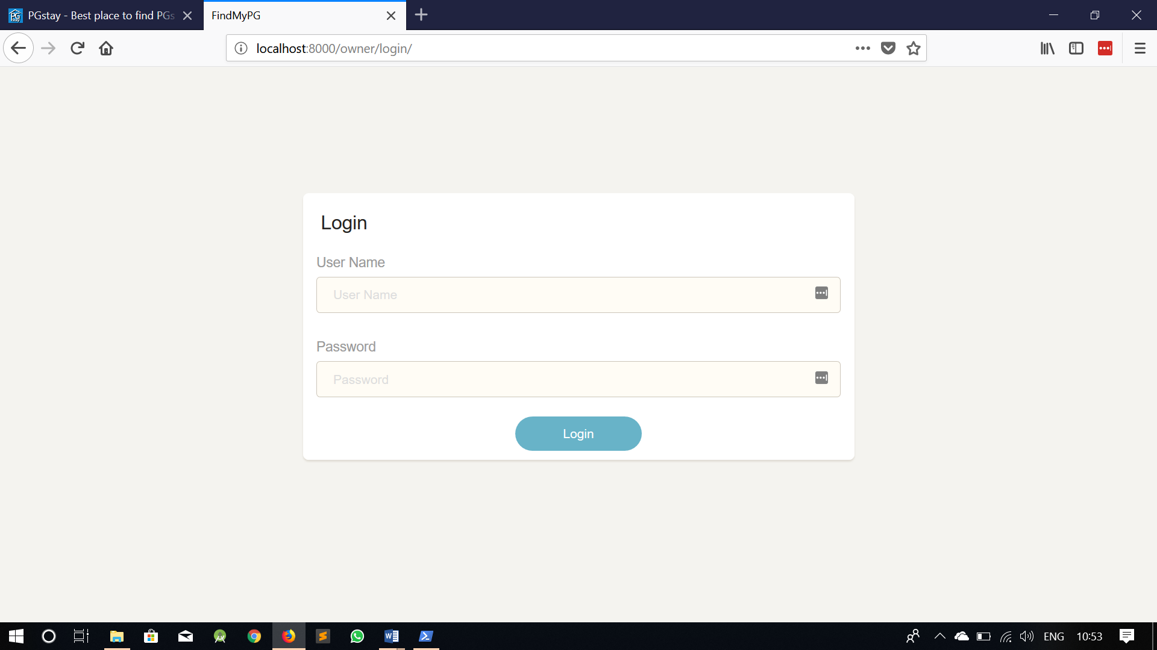

**Login Screen With Invalid User name and Password**

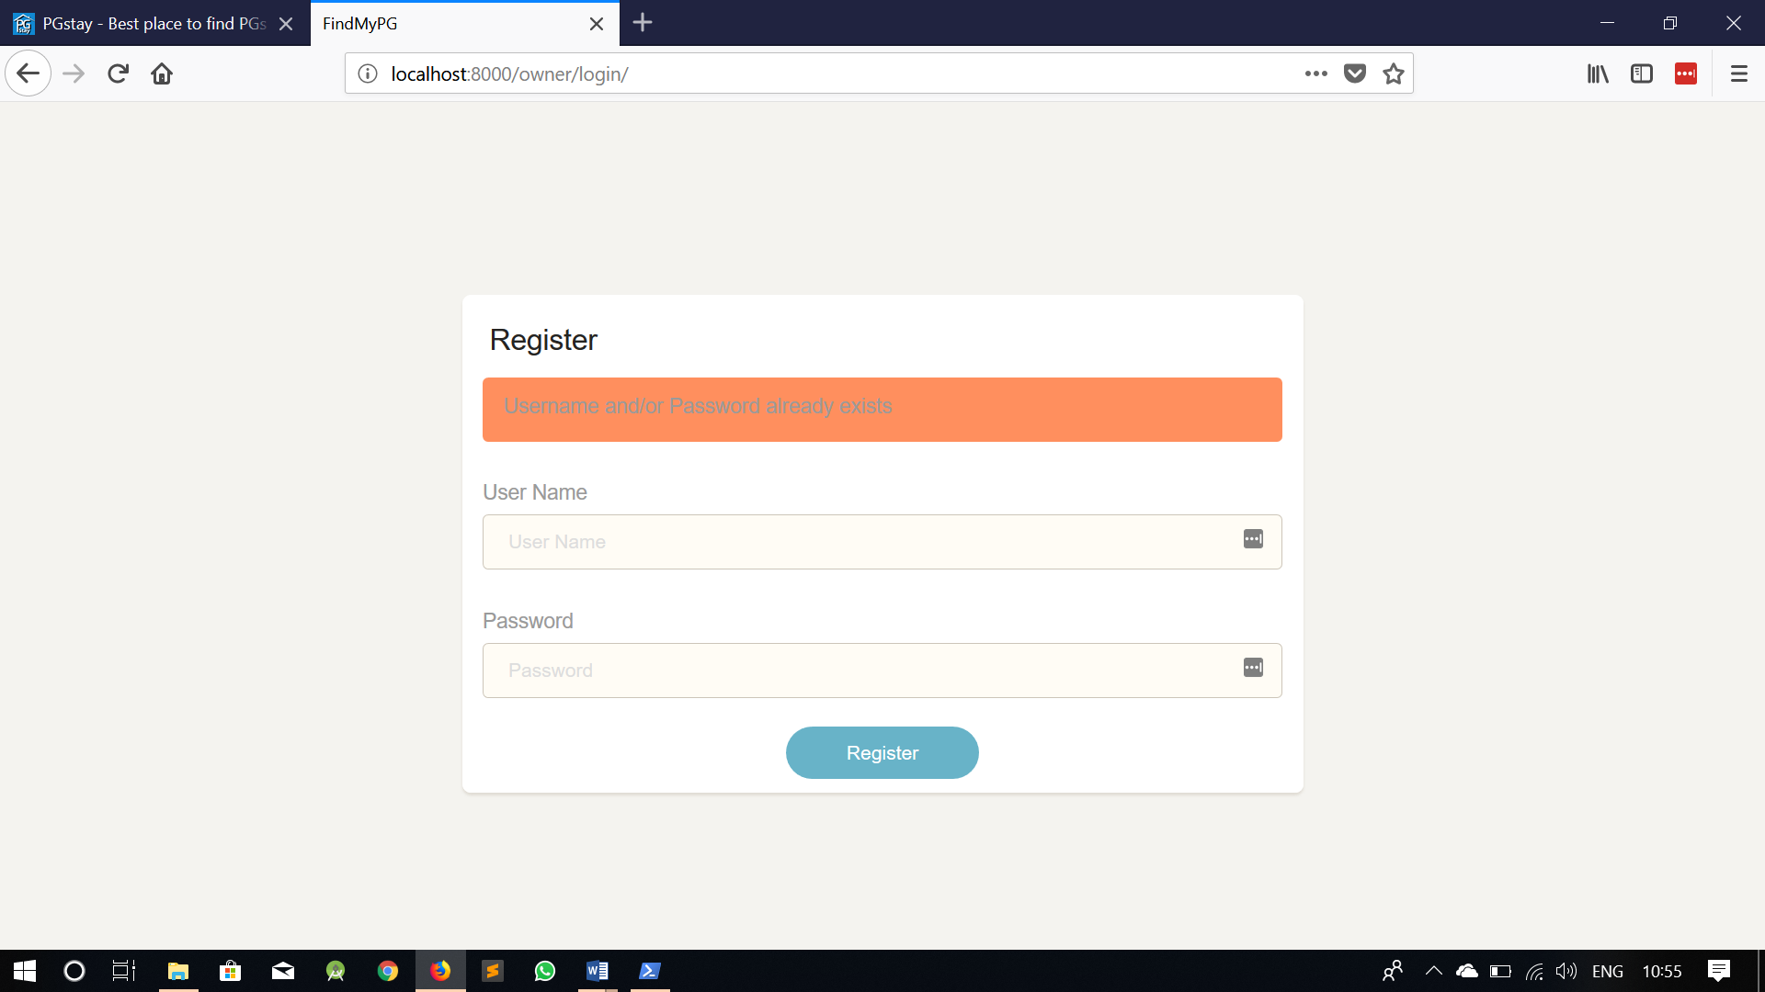**Owner Register Screen**

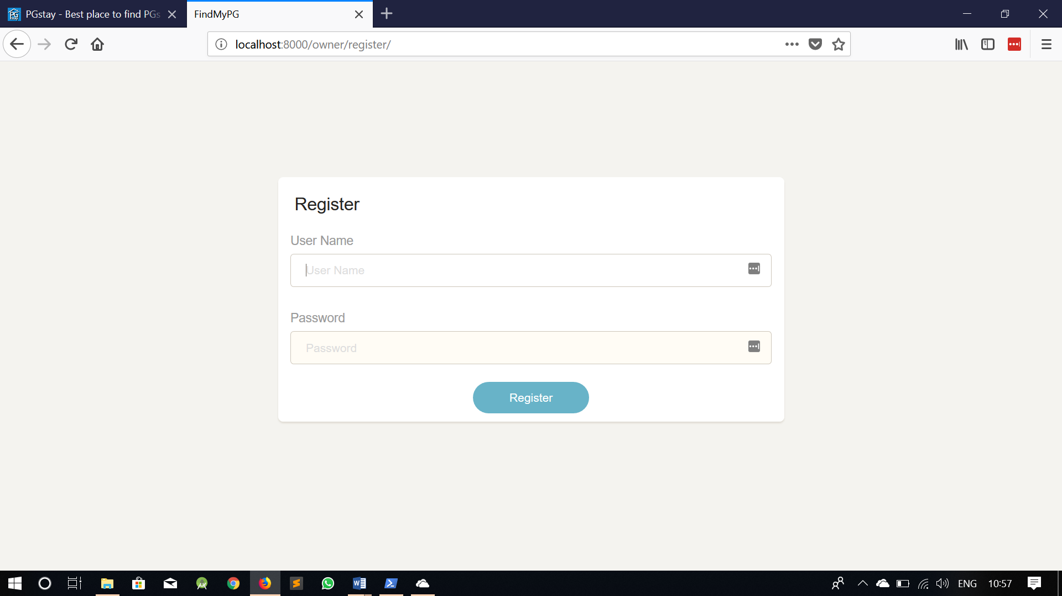

**Register Screen After successful Registration**

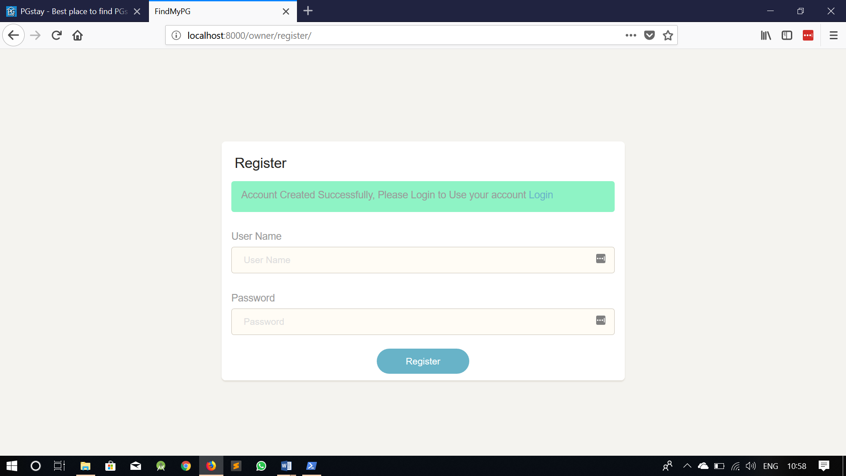

**Register Screen with Duplicate Data**

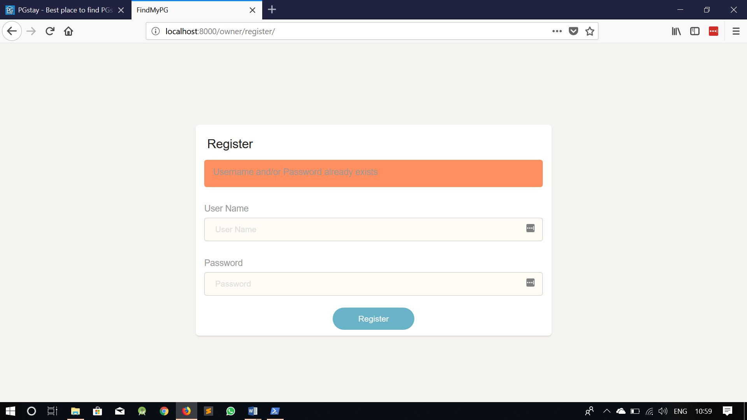**Owner Dashboard**

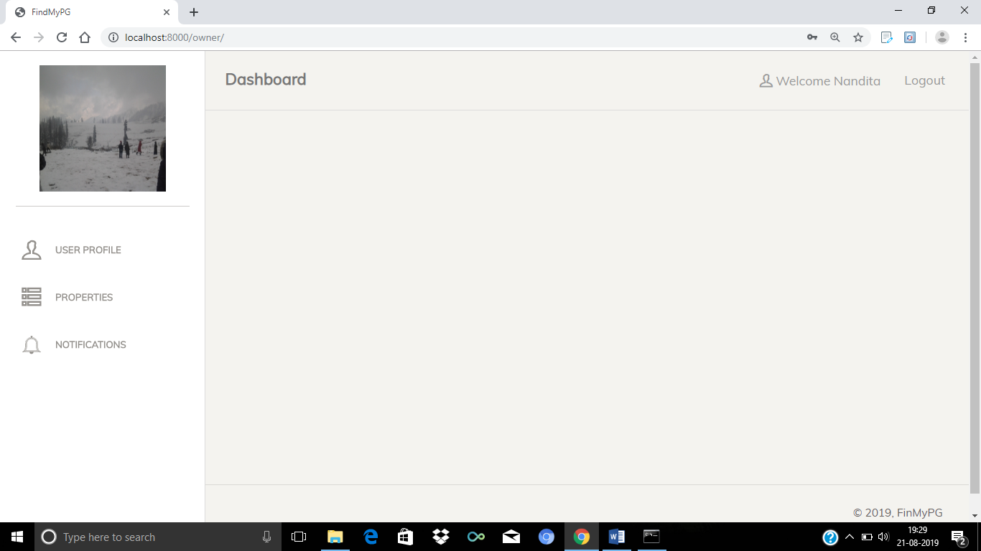

**Upload Profile Photo Screen**

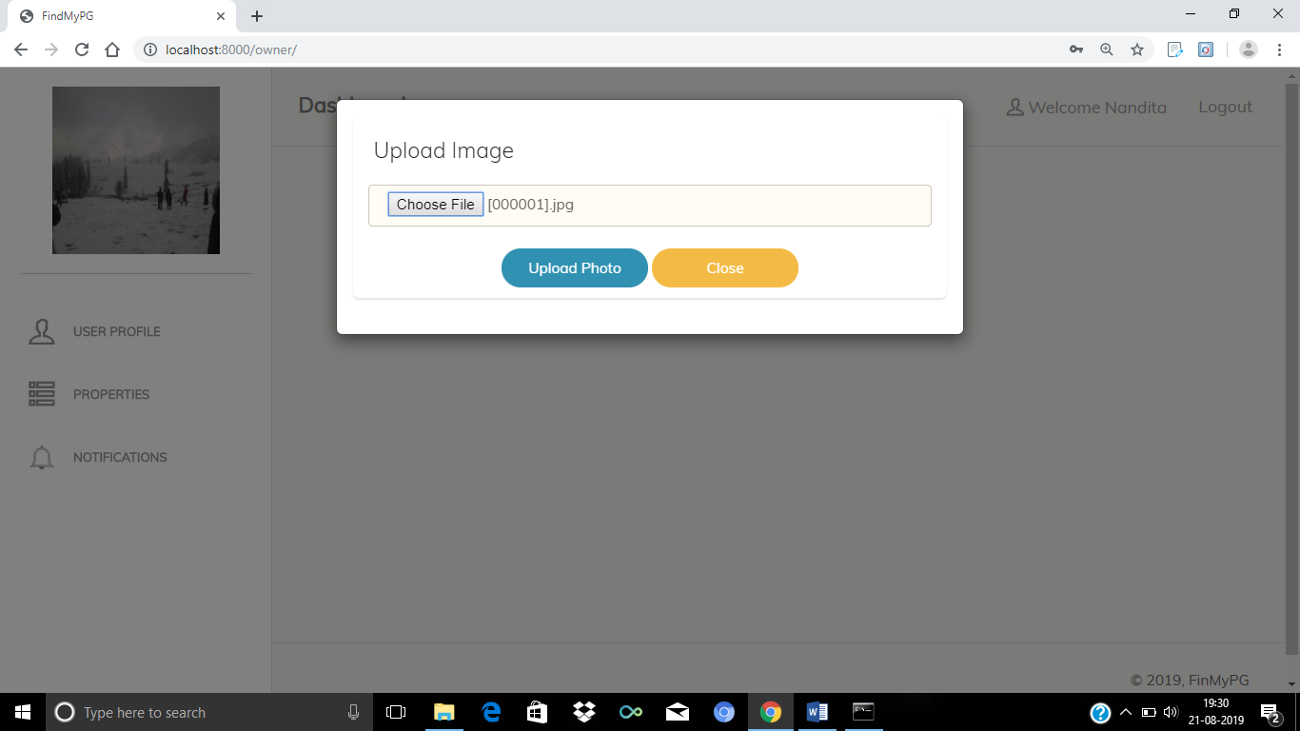**Update Profile Screen**

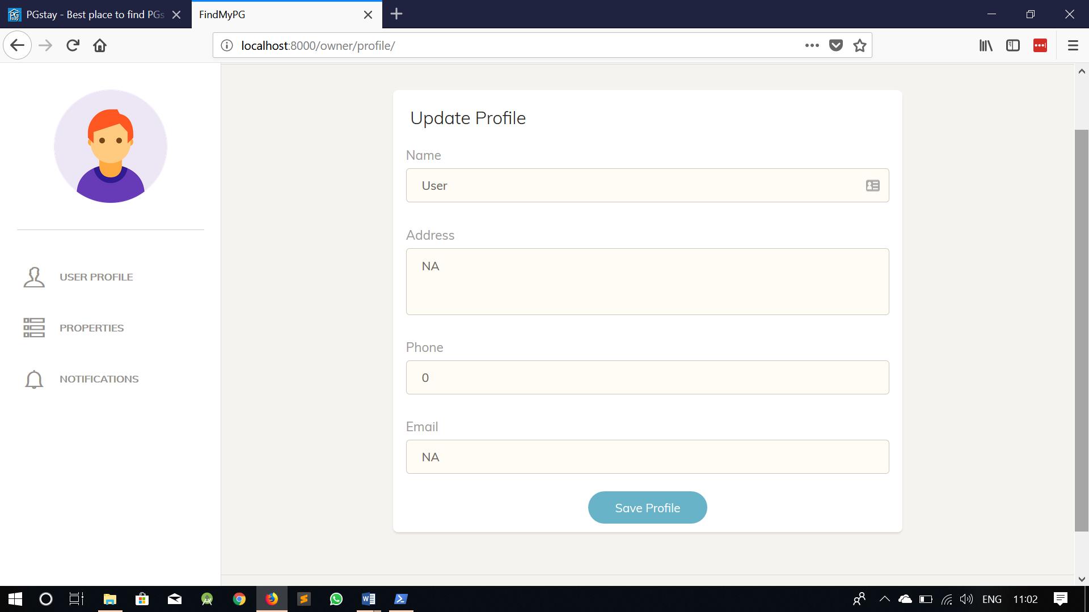

**Owner Add PG Page**

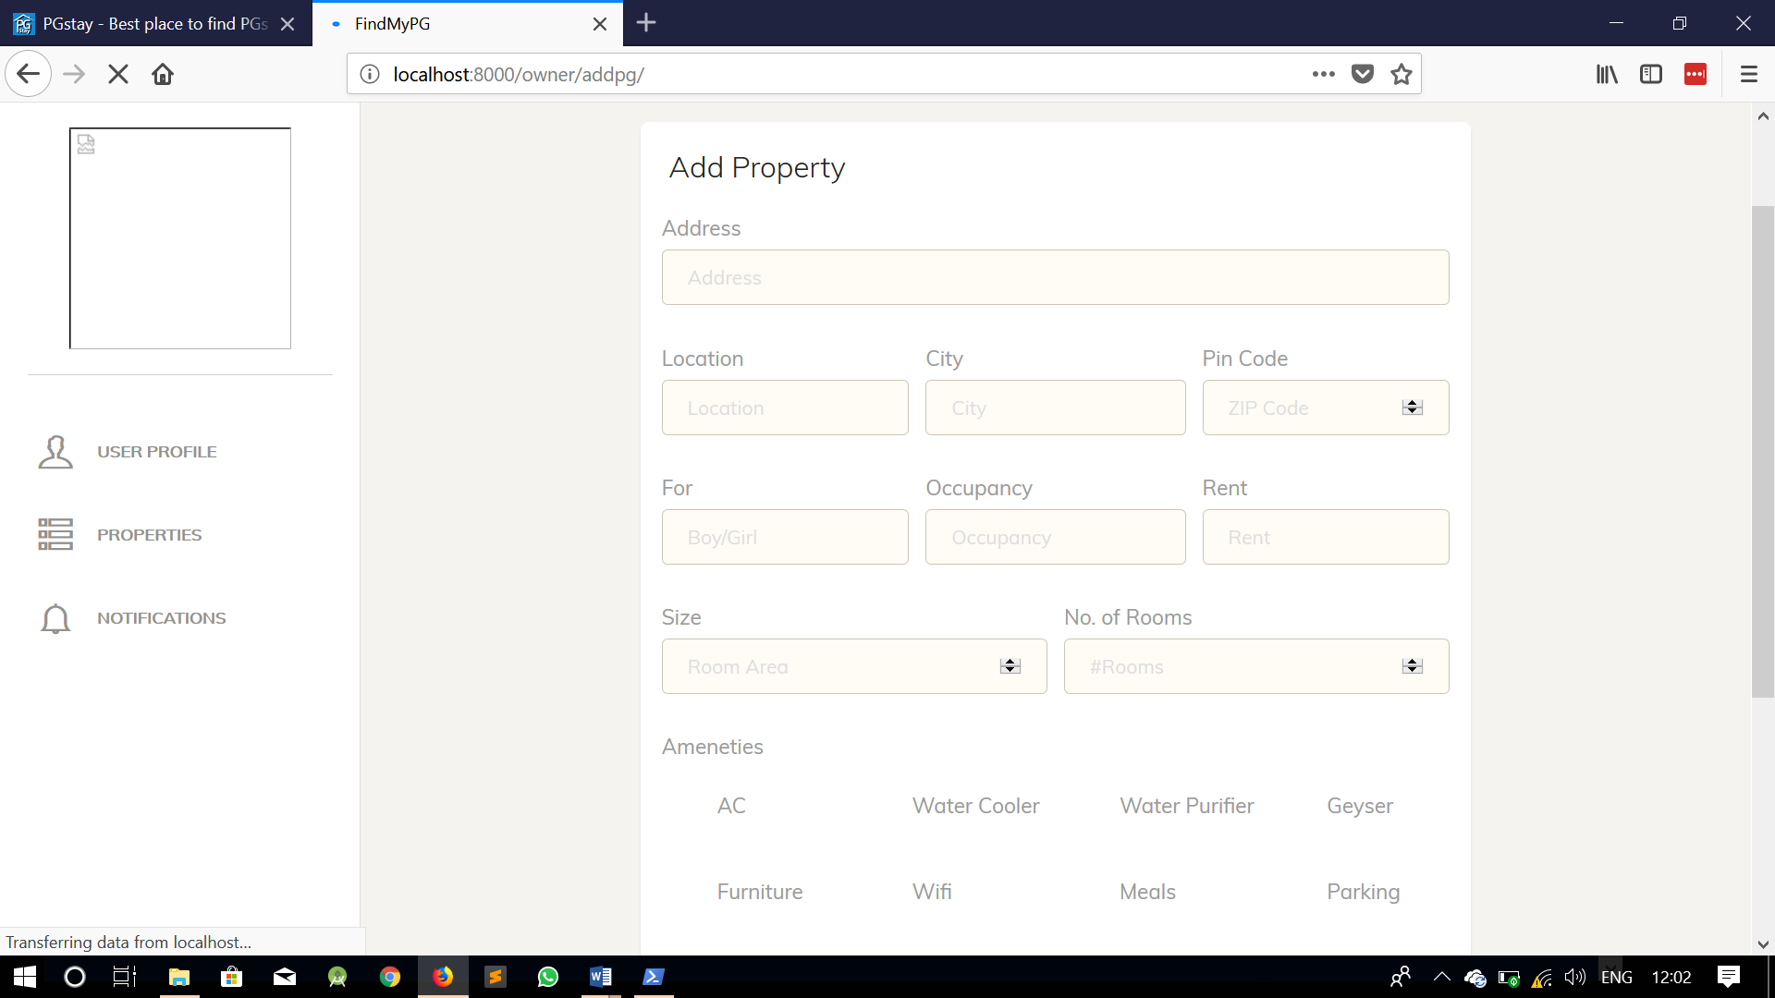

**User Home Screen**

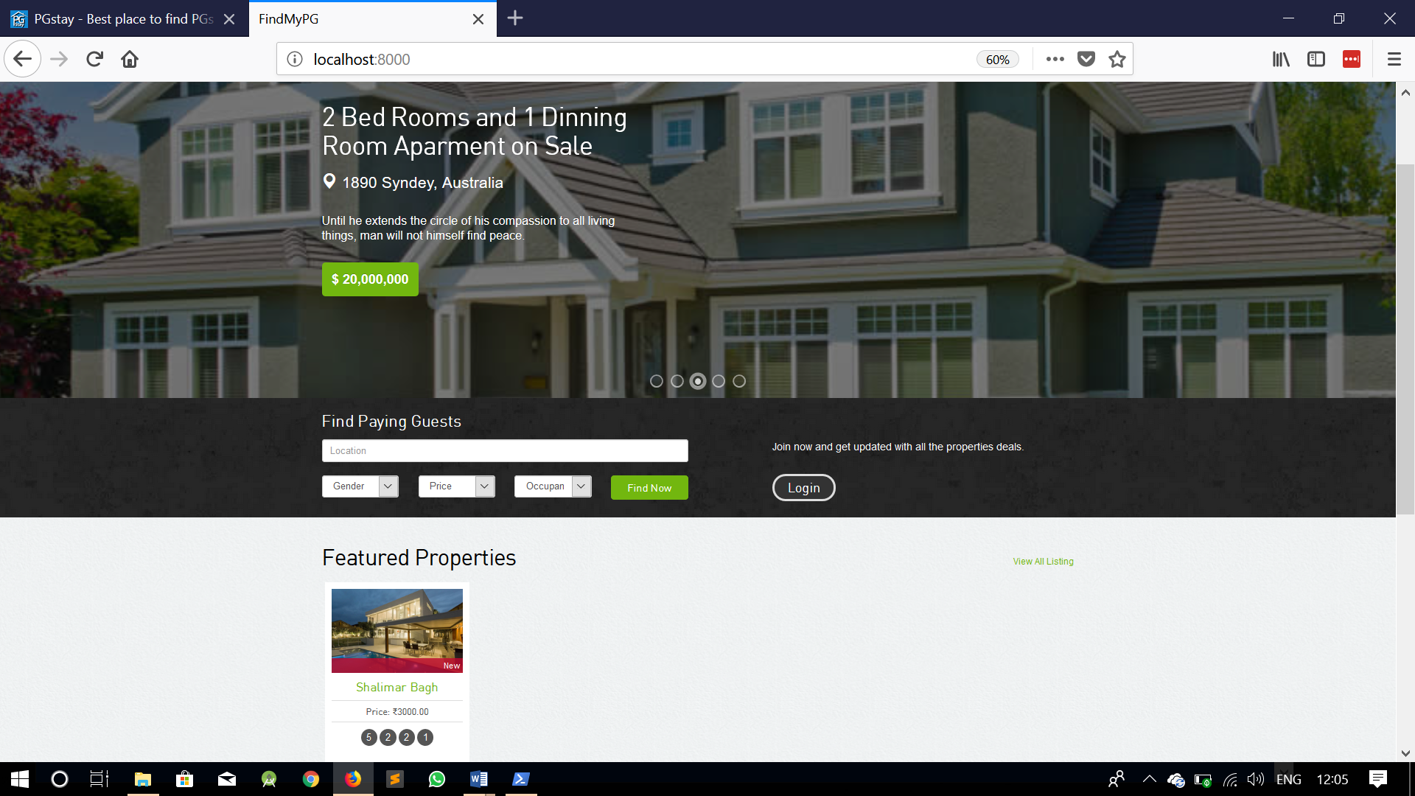

**Search Screen**

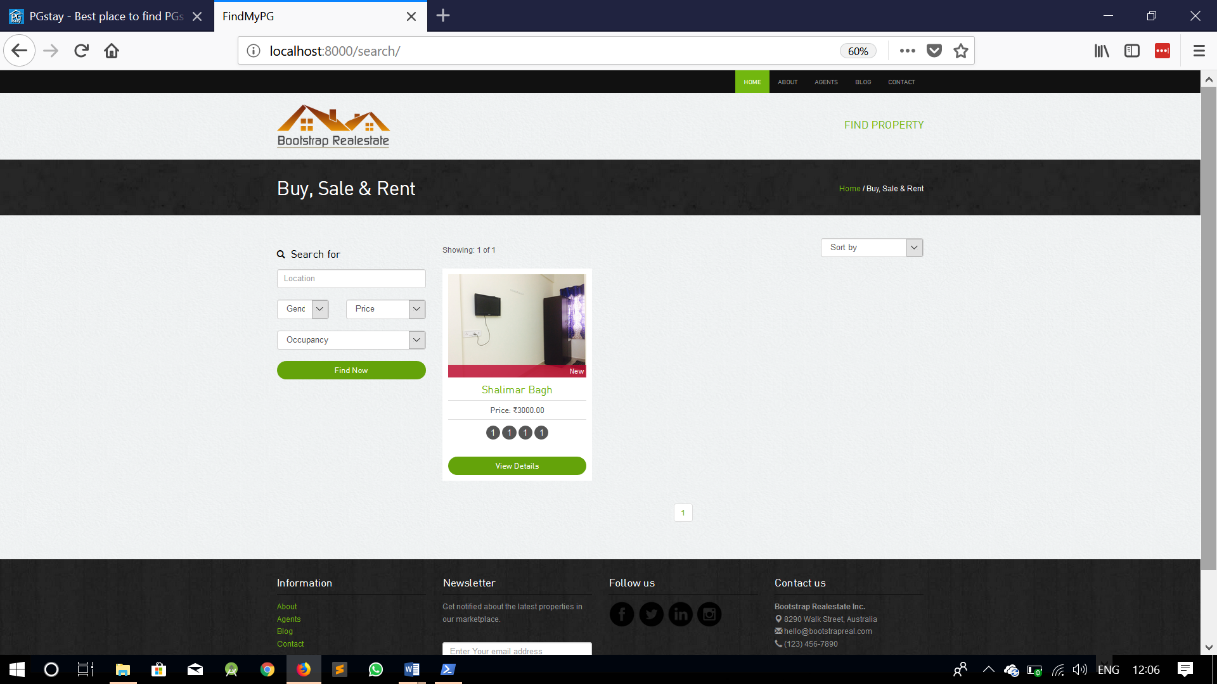

**Property Details Screen**

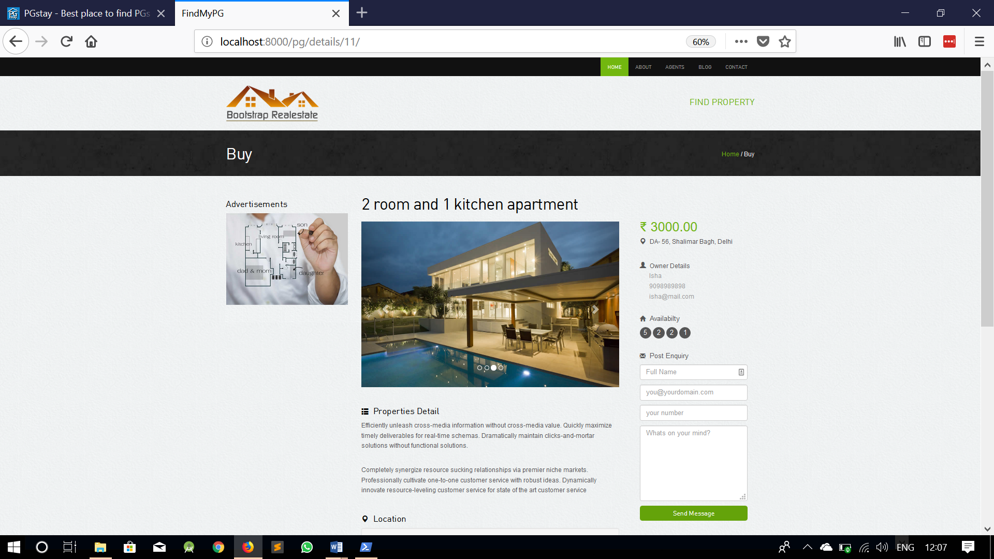

**Chapter-8**

**TESTING**

**CHAPTER-8 TESTING**

“Testing is the major quality control measure used during software development”. “Its basic function is to etect errors in the software”. “During requirement analysis and design, the output is a docment that is usualyy textural and non-exucatable”.

“After the coding phase, computer programs are available that can be executed for testing purposes”. “This implies that testing not only has to uncover errors introduced during coding, but also errors introduced during the previous phases”.

“Thus, the goal of testing is to uncover requirement, design and coding errors in the program. Consequently, different levels of testing are used”.

“Testing is carried out because”:

1. “A phase in which the errors remaining in the previous phases must be eliminated”.
2. “Helps in critical manner for quality assurance, ensuring the reliability of software”.
3. “Represents a critical review of Spcecifications, Design and Coding”.
4. “Destructive rther than constructive (try to break the system)”
5. “Major objective is to find errors not to show the absence of errors (as distinct from Verification and Validation)”

**8.1 Testing Methodology**

* **Unit testing**: “This is the lowest level of testing that is conducted to remove syntax & logic errors from a single unit”. “Individual components are tested to ensure that they operate correctly. Each component is tested independently, without other system components”.
* **Module testing**: ““A module is a collection of dependent components such as an object class, an abstract data type or some looser collection of procedures & functions””. “A module encapsulates related components, so can be tested without other system modules”.
* **Sub-System testing**: “This phase involves testing collections of modules, which have been integrated into sub-systems”. “This tests for problems that arise from component interactions”. “This testing should begin as soon as usable versions of some of the system components are available”.
* **System testing**: “The sub-systems are integrated to make up the system”. “The system as a complete entity is tested over here”. “This process is concerned with finding errors that result from unanticipated interactions between sub-systems. It is also concerned with validating that the system meets its functional & non-functional requirements & testing the emergent system properties”.
* **Acceptance testing**: “This is the final stage in the testing process before the system is accepted for operational use”. “The system is tested with data supplied by the system customer rather than simulated test data”. “Acceptance testing may reveal errors & omissions in the system requirements definition because the real data exercise the system in different ways from the test data”. “It may also reveal requirements problems where the system’s facilities do not really meet the user’s needs or the system performance is unacceptable”.

**8.2 Testing Techniques**

* **Black Box Testing: “**It aims at testing a given program’s behavior against its specification or component without making any reference to the internal structures of the program or the algorithms used”.

“Therefore, the source code is not needed. We study the system by examining its inputs and related outputs”.

“The test designer selects valid and invalid inputs and determines the correct ouptput. There is no knowledge of the test object’s internal structure”.

* **White Box Testing: “**White box testing is a method of testing software that tests internal structures or workings of an application”.

“In white-box testing an internal perspective of the system, as well as programming skills, are used to design test cases”. ,,The tester chooses inputs to exercise paths through the code and determine the appropriate outputs”.

“It is usually done at the unit level”. “It can test paths within a unit, paths between units during integration, and between subsystems during a system-level test”.

“Though this method of test design can uncover many errors or roblems, it might not detect unimplemented parts of the specifiacation or missing requirements”.

**Chapter-9**

**Maintainance and Evalution**

**CHAPTER-9 Maintainance and Evalution**

**9. Introduction**

“Maintenance is the process of eliminating errors in the working system during its working life and to tune the system to any variation in working environment”. “By proper maintenance, system can bring to new standards”. “As my project is error free and produce no bugs for valid data”, “but I use feature to detect the errors and produce error messages understand by the experienced user and nonprogrammer user”.

“This phase occurs once the system is operational”. “Maintenance of software in software engineering is the modification of software product after delivery to correct faults”, “to improve performance or for other attributes”. “A common perception of maintenance is that it involves fixing defects”. “Maintenance is a broad activity that includes”:

* Error Correction
* Enhancements of capabilities
* Deletion of obsolete capabilities
* Optimization
* Fixing faults
* Resource management

“Change is inevitable, mechanisms must be developed for evaluation, controlling and making modifications”.

“Any work done to change the software after it is in operation is considered to be maintenance work”. “The main goal is to preserve the value of software over the time”.

**9.1 Importance**

“Maintenance is the integral part of software, which requires an accurate maintenance plan to be prepared during the software development”. “The plan should specify how the users will request modifications and report problems”.

“The key maintenance issues are both managerial and technical and key management issues are”: “alignment with customer priorities, staffing, which organization does maintenance”, “estimating costs”. “The key technical issues are”: “limited understanding, impact analysis, testing, maintain ability measurement”.

**9.2 Maintenance Processes**

Software Maintenance processes are:

* “The Software Maintenance process includes a maintenance plan which contains software preparation, problem identification, and find out about product configuration management”.
* “The problem analysis process includes checking validity”, “examining it and coming up with a solution and finally getting all the required support to apply for modification”.
* “The process acceptance by confirming the changes with the individual who raised the request”.
* “The platform migration process, which is used if software is needed to be ported to other platform without any change in functionality”.

Some Software points affect maintenance costs are:

* Structure of software program
* Programming language
* Dependence on external environment
* Staff reliability and availability

**Chapter-10**

**Conclusion and Discussion**

**CHAPTER 10 CONCLUSION AND DISCUSSION**

**10.1. Future Scope of the Project**

Every system has some elements of improvement, whether new or existing. FindMyPG provides its users a system that is fully developed can cater to all their needs. But as already mentioned every system has some elements of improvement.

At present FindMyPG does not provide online sale of properties. But in the future versions it can be ensured that properties can directly booked online by paying the token money. Sale and Purchase of any property can only happen after the verification of the property. Here Property Bazaar will ensure that both buyer and seller are legitimate and they actually want to sale/purchase property.

Account verifications can also be added in the future versions, where every account will be verified before it can actively transact on the portal. Users will also be asked to provide copies of their documents to verify their true identity.

Users will also be notified via the SMSes and/or emails, directly for any updation in their profiles, or whenever someone will show interest in their properties. At present users can only notified via the telephonic calls.

**10.2. “Self-Analysis of Project Viabilities”**

Definitely, it's cheaper to use online Mobile shopping for both personal and business use because most of it is usually free”.

**10.3. “Problem Encountered and Possible Solutions”**

* **“Hardware Limitations”**

“The only limitation posed is when the disk space is exhausted. And it can be solved by extending the disk space”.

* **Internet speed**

**“**Internet connection speed should be minimum 128 kbps”.

**10.4. Summary `**

**of Project work**

“In whole procedure to prepare project, we first gather the requirement of the project and decide the time schedule”. “After planning we design the documentation of project”. “After the design, we generate the code of system”. “In design, the code we do the error estimation and effort estimation”. “If error is occuring then solve it”. “Finally, when code is designed then test the project and decide the cost of project”.

**References/Bibliography**

**Author:**

* Software Engineering: A Practioner’s Approach 6th edition by Roger Pressman, McGraw Hill international edition.
* The Object-Oriented Approach Concepts, System Development and Modeling with UML, Satzinger, Orvik, 2nd edition.

**Web Links:**

* [www.](http://www.infosurv.com)google.com
* www.wikipedia.com
* www.real-estate-management-system.nic.in
* www.project-management-basics.com